

A Project Report on

Automation testing using Selenium WebDriver

On Demo Guru99 Mercury Tours

By

KAALI SANDHYA

Batch- EON (2020-5344)

Under the Guidance of,

Priyanka Desle

(Technical Trainer)

At

Edubridge India Pvt Ltd

**Introduction**

This Project aims to do overall testing like functional testing, GUI testing on website to check quality of application. It helps to improve quality of website and saves time for manually doing this testing. In this project our main focus is to check functionalities available on website. Also it includes title check and all links count with their working status.

Operating System : Window 10

Browser : Mozilla Firefox Version **90.0**

IDE : Eclipse IDE 8.1

Language : Java

Framework : Selenium

TC_01-unch the browser and open Guru99 Website

TC_01-Launch the browser and open Guru99 Website

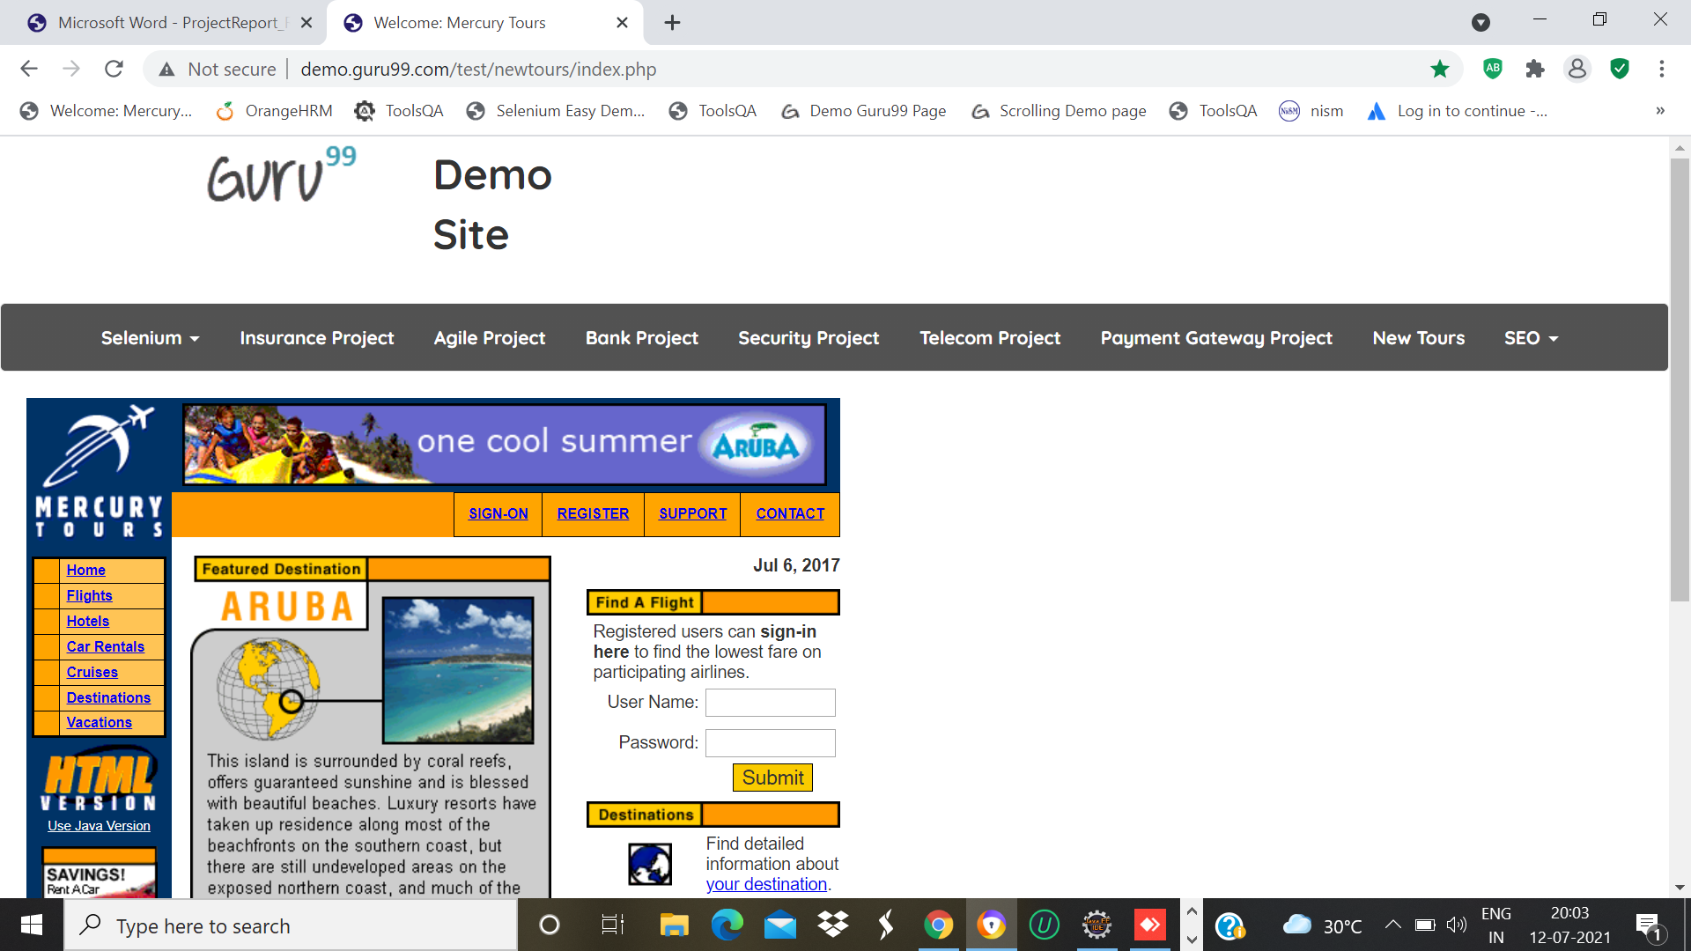

System.*setProperty*("webdriver.gecko.driver","C:\\Users\\win 10\\Desktop\\Selenium jar\\geckodriver.exe");

WebDriver w=**new** FirefoxDriver();

Thread.*sleep*(2000);

w.get("http://demo.guru99.com/test/newtours/index.php");

TC_02-Open Login Page

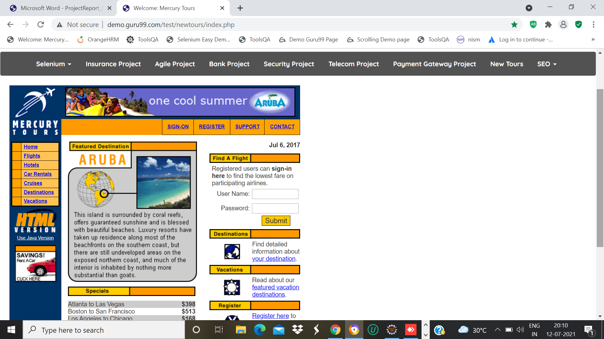

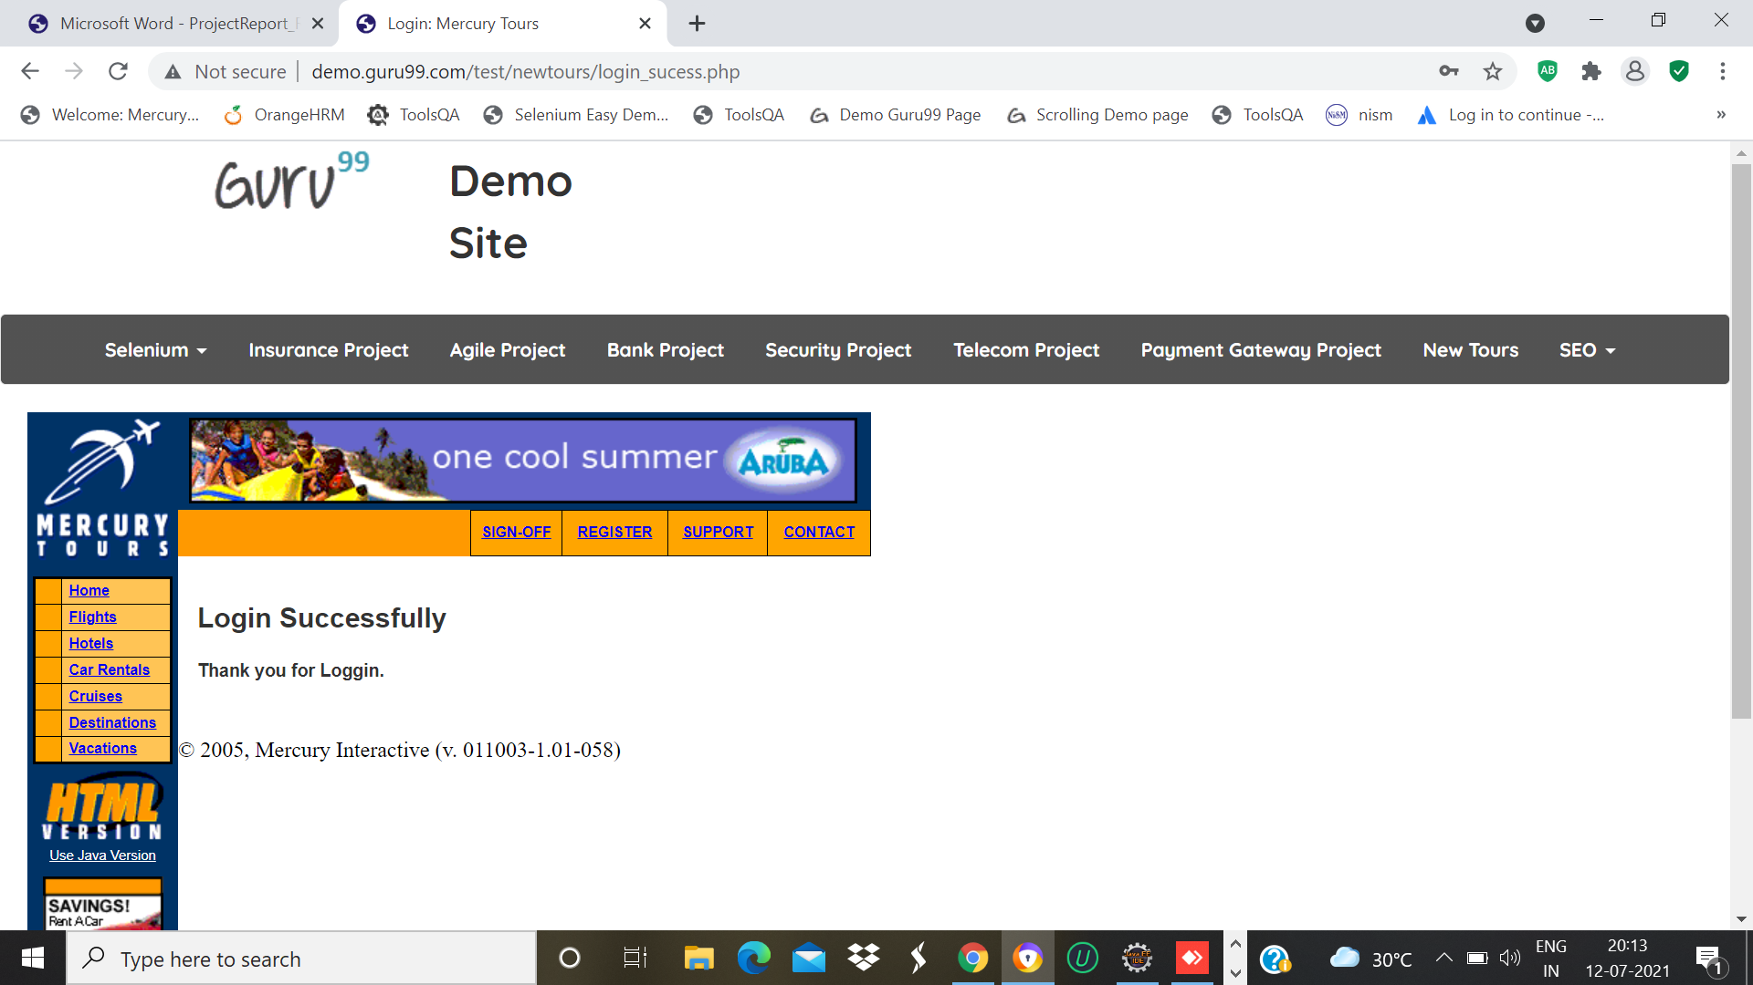

w.findElement(By.*name*("userName")).sendKeys("test");

w.findElement(By.*name*("password")).sendKeys("test");

w.findElement(By.*name*("submit")).click();

System.***out***.println("webpage is working");

System.***out***.println(w.getCurrentUrl());

System.***out***.println(w.getTitle());

w.navigate().back();

Thread.*sleep*(3000);

TC_03- To Check Functionality of Sign-on Page

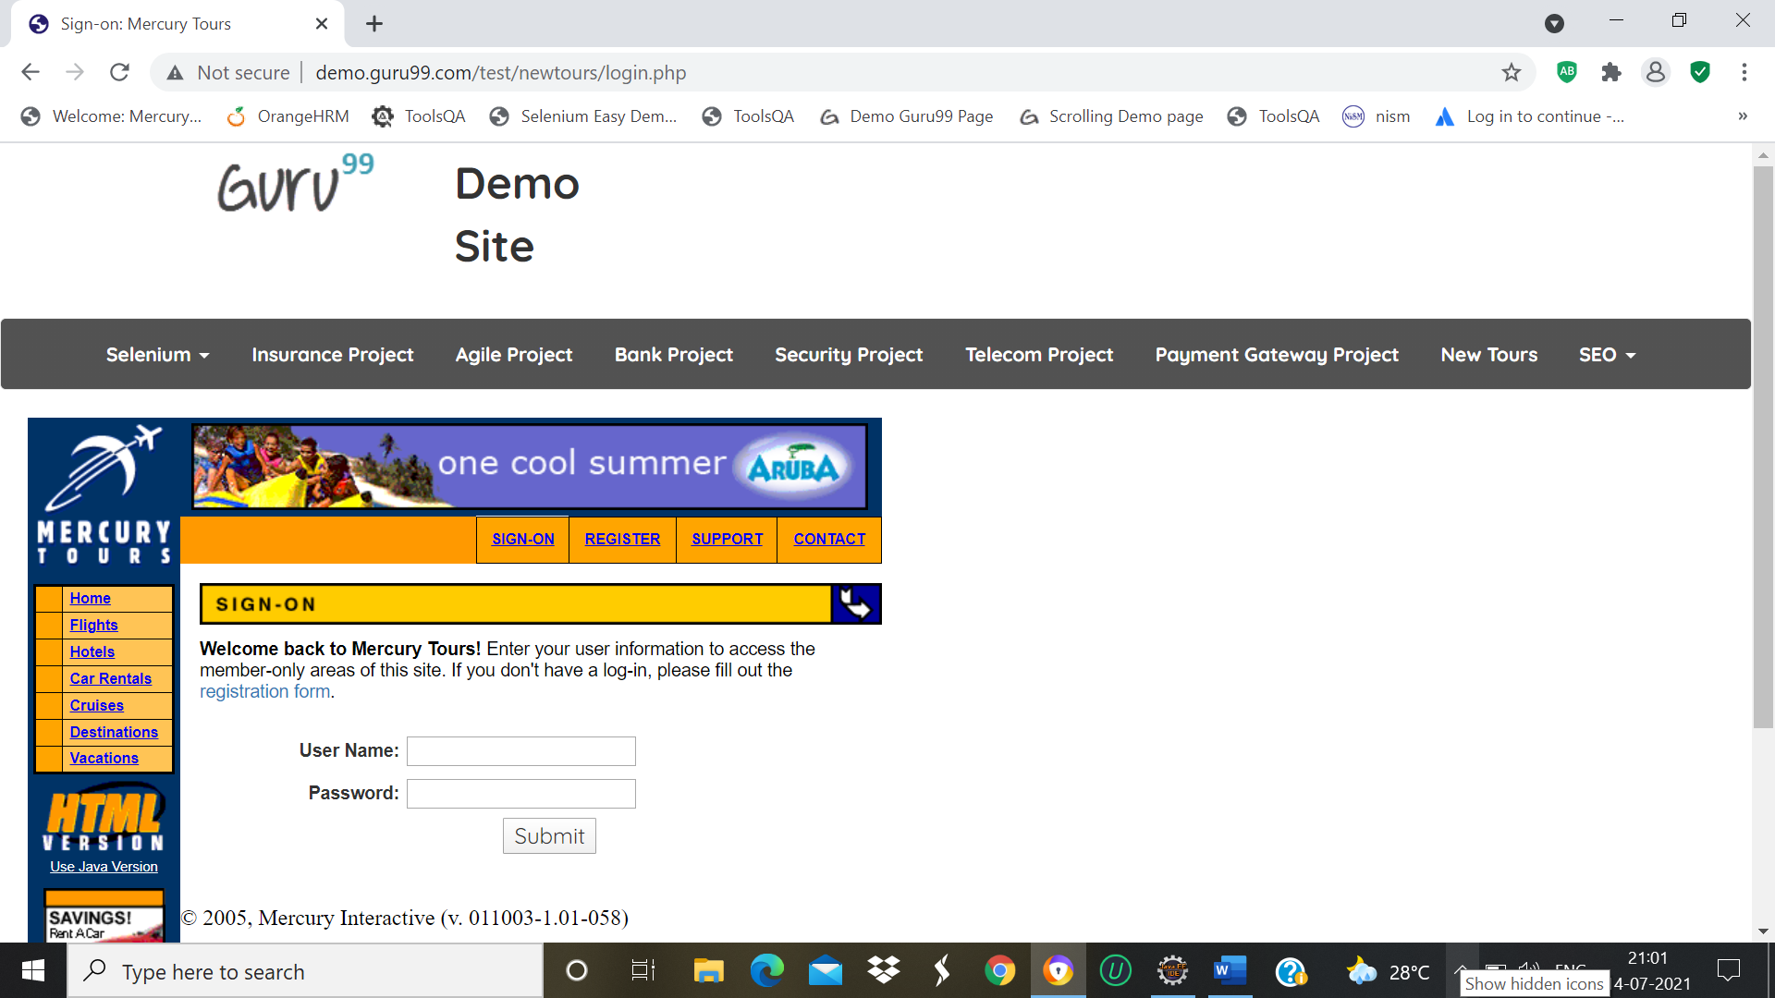

w.findElement(By.*xpath*("/html/body/div[2]/table/tbody/tr/td[2]/table/tbody/tr[2]/td/table/tbody/tr/td[1]/a")).click();

w.findElement(By.*name*("userName")).sendKeys("1234");

w.findElement(By.*name*("password")).sendKeys("1234");

w.findElement(By.*name*("submit")).click();

System.***out***.println("signon");

w.navigate().back();

w.navigate().back();

DEFECT: Login button is not working properly

TC_4 To check the Functionality of the Sign_off Button

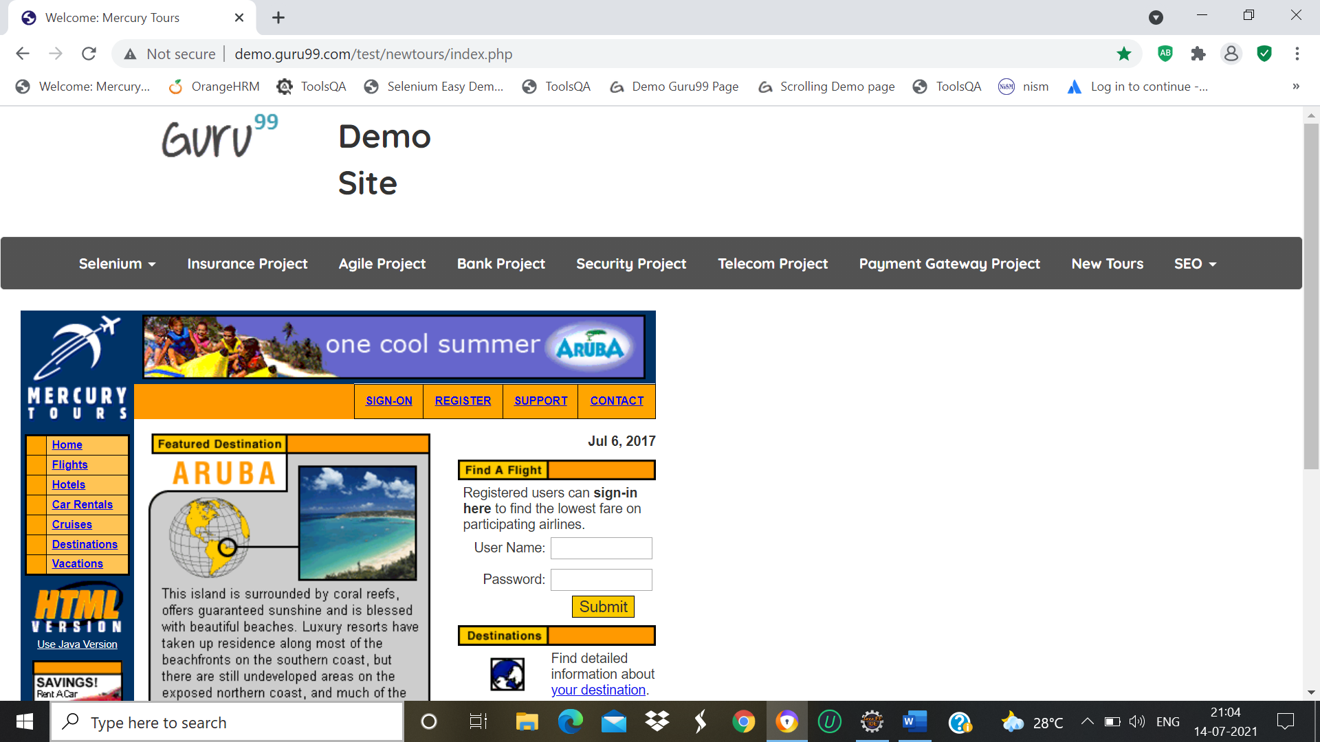

System.out.println(w.findElement(By.xpath("/html/body/div[2]/table/tbody/tr/td[2]/table/tbody/tr[4]/td/table/tbody/tr/td[2]/table/tbody/tr[1]/td/h3")).getText());

w.findElement(By.linkText("SIGN-OFF")).click();

w.navigate().back();

System.out.println("signon");

w.navigate().back();

w.navigate().back()

TC_5 To check the Functionality of the Register Page

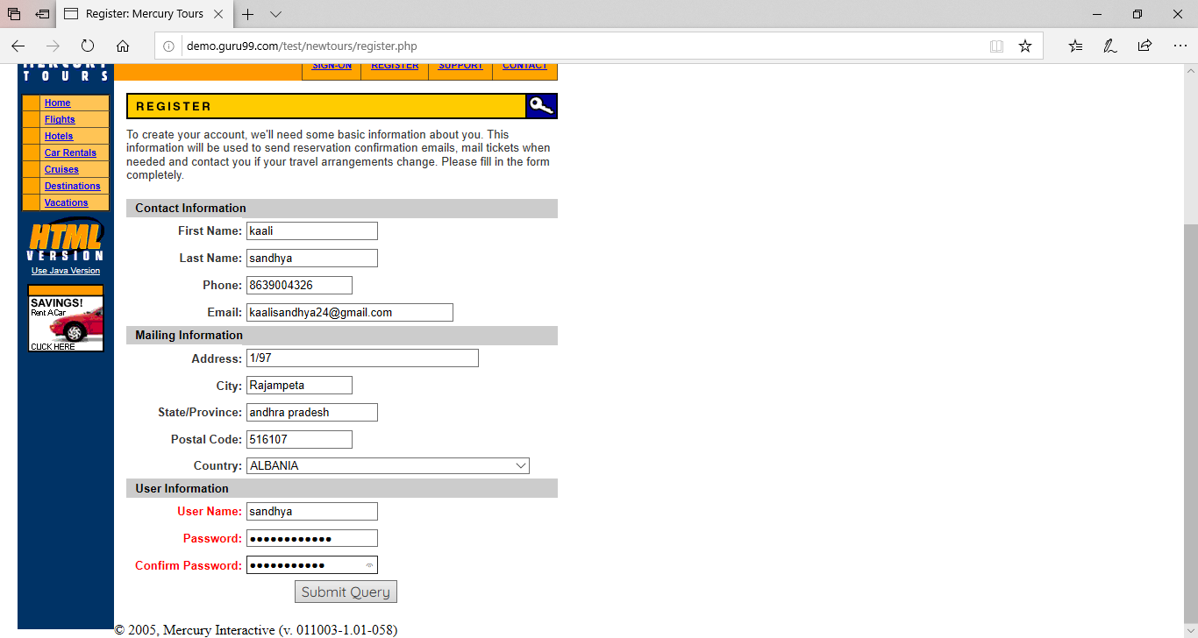

w.findElement(By.*linkText*("REGISTER")).click();

Thread.*sleep*(4000);

w.findElement(By.*linkText*("REGISTER")).click();

w.findElement(By.*name*("firstName")).sendKeys("kaali");

w.findElement(By.*name*("lastName")).sendKeys("sandhya");

w.findElement(By.*name*("phone")).sendKeys("1234546578");

w.findElement(By.*name*("userName")).sendKeys("kaalisandhya@gmail.com");

w.findElement(By.*name*("address1")).sendKeys("Ananthaiahgaripalli");

w.findElement(By.*name*("city")).sendKeys("kadapa");

w.findElement(By.*name*("state")).sendKeys("andhra pradesh");

w.findElement(By.*name*("postalCode")).sendKeys("516107");

Select s=**new** Select(w.findElement(By.*name*("country")));

s.selectByIndex(13);

s.selectByValue("AUSTRIA");

s.selectByVisibleText("AUSTRIA");

w.findElement(By.*name*("email")).sendKeys("kaalisandhya@gmail.com");

w.findElement(By.*name*("password")).sendKeys("1111112");

w.findElement(By.*name*("confirmPassword")).sendKeys("1111112");

w.findElement(By.*name*("submit")).click();

w.navigate().back();

System.***out***.println("Register");

Thread.*sleep*(4000);

w.navigate().back();

TC_6 To check the Functionality of the support page.

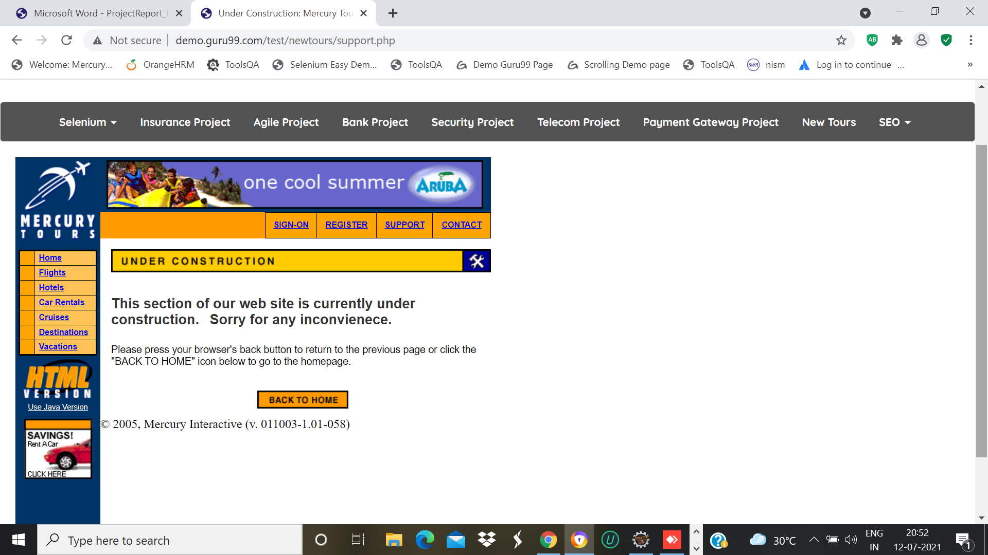

w.findElement(By.*linkText*("SUPPORT")).click();

Thread.*sleep*(3000);

w.navigate().back();

System.***out***.println("support");

Thread.*sleep*(3000);

TC_07-To Check the functionality of Contact Page

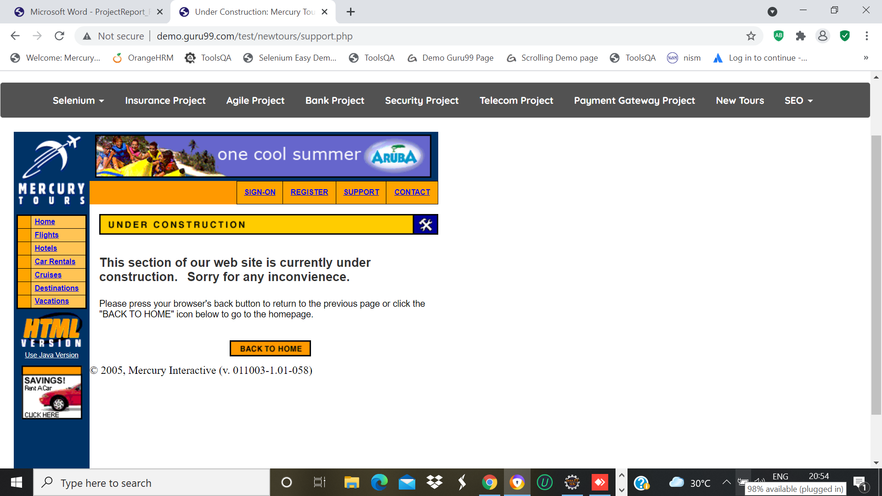

w.findElement(By.*linkText*("SUPPORT")).click();

Thread.*sleep*(3000);

w.navigate().back();

System.***out***.println("support");

Thread.*sleep*(3000);

TC_08-To Check the functionality of Home Page

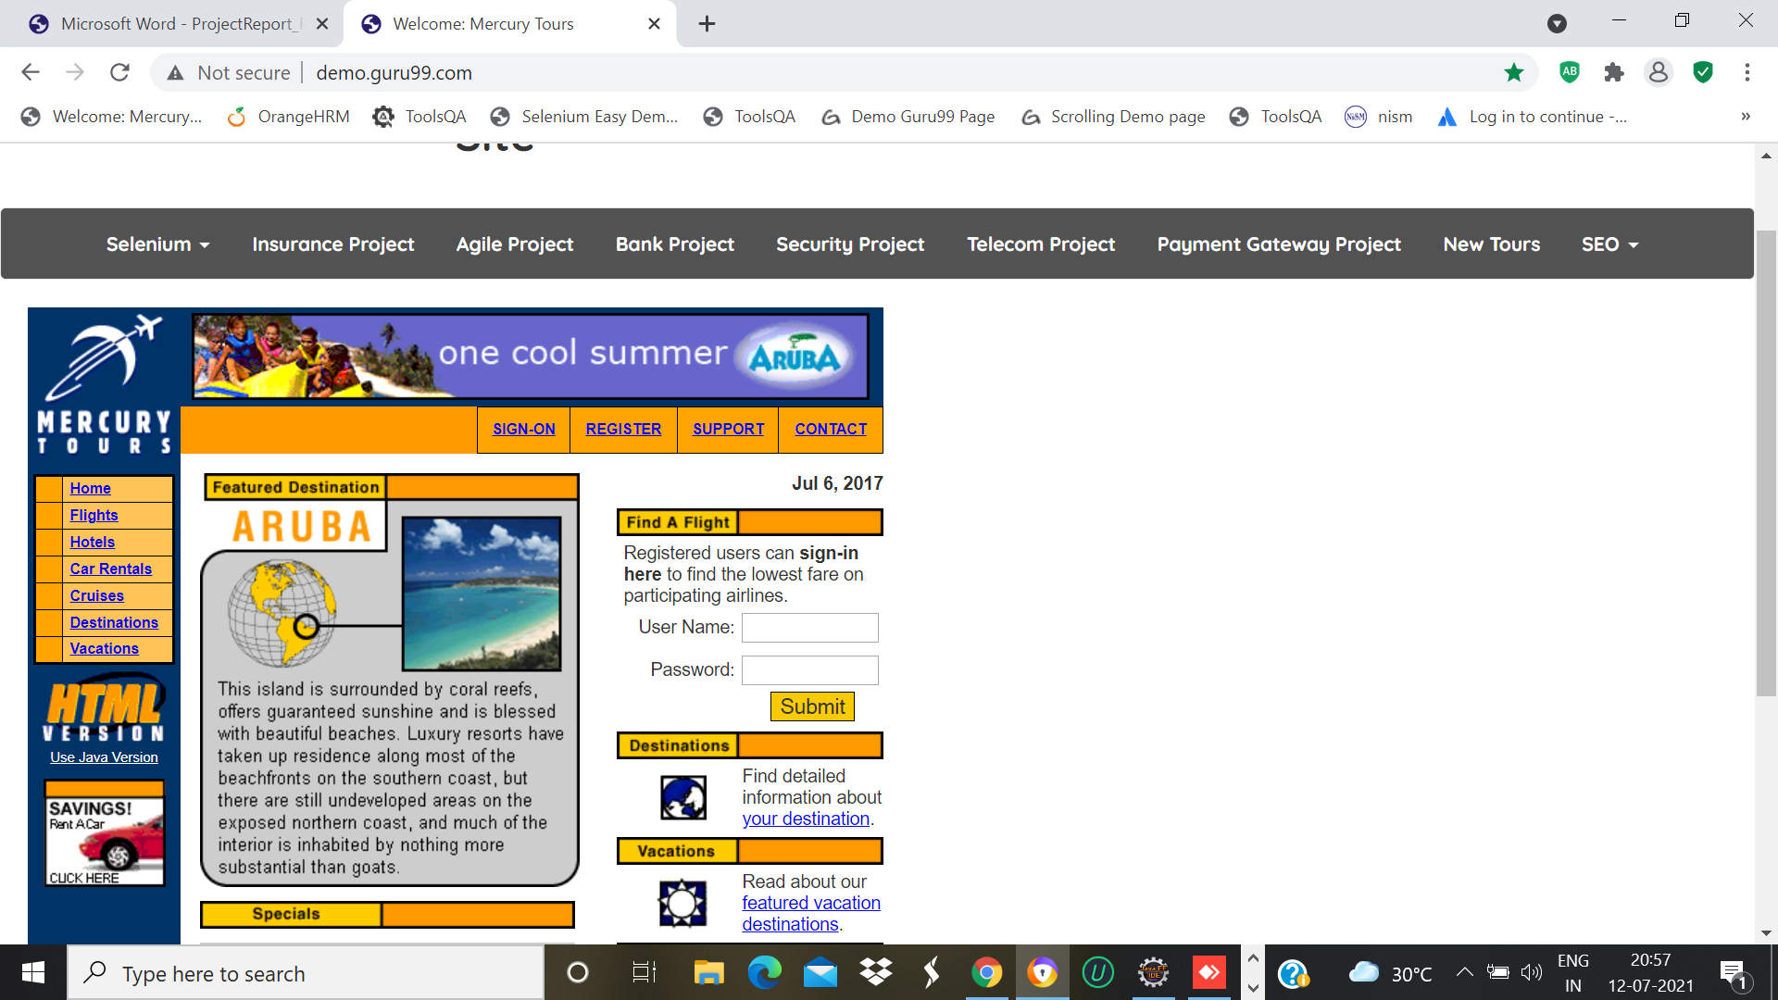

w.findElement(By.*linkText*("Home")).click();

Thread.*sleep*(3000);

System.***out***.println("home");

TC_09-Check the functionality of Flights Page

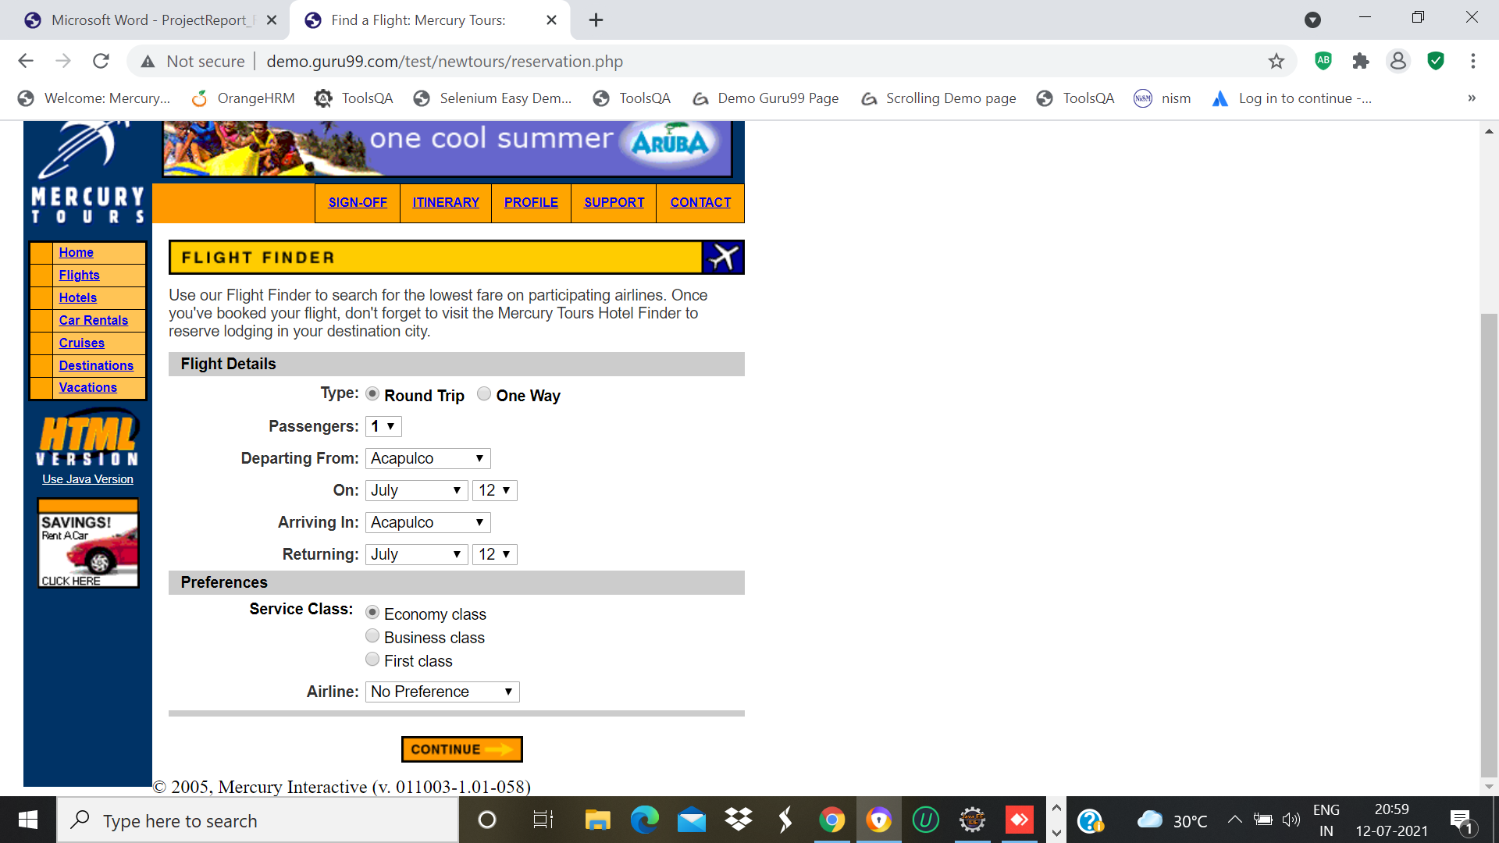

w.findElement(By.*linkText*("Flights")).click();

Thread.*sleep*(3000);

w.findElement(By.*xpath*("/html/body/div[2]/table/tbody/tr/td[2]/table/tbody/tr[4]/td/table/tbody/tr/td[2]/table/tbody/tr[5]/td/form/table/tbody/tr[2]/td[2]/b/font/input[1]")).click();

System.***out***.println("radio button");

Select s0=**new** Select(w.findElement(By.*name*("passCount")));

s0.selectByIndex(0);

Select s1=**new** Select(w.findElement(By.*name*("fromPort")));

s1.selectByIndex(2);

Select s2=**new** Select(w.findElement(By.*name*("fromMonth")));

s2.selectByIndex(5);

Select s3=**new** Select(w.findElement(By.*name*("fromDay")));

s3.selectByIndex(14);

Select s4=**new** Select(w.findElement(By.*name*("toPort")));

s4.selectByIndex(5);

Select s5=**new** Select(w.findElement(By.*name*("toMonth")));

s5.selectByIndex(6);

Select s6=**new** Select(w.findElement(By.*name*("toDay")));

s6.selectByIndex(19);

w.findElement(By.*xpath*("/html/body/div[2]/table/tbody/tr/td[2]/table/tbody/tr[4]/td/table/tbody/tr/td[2]/table/tbody/tr[5]/td/form/table/tbody/tr[9]/td[2]/font/font/input[1]")).click();

Select s7=**new** Select(w.findElement(By.*name*("airline")));

s7.selectByIndex(2);

w.findElement(By.*name*("findFlights")).click();

w.navigate().back();

System.***out***.println("flights");

Thread.*sleep*(3000);

w.navigate().back();

TC_10-To check the Functionality of Hotels page

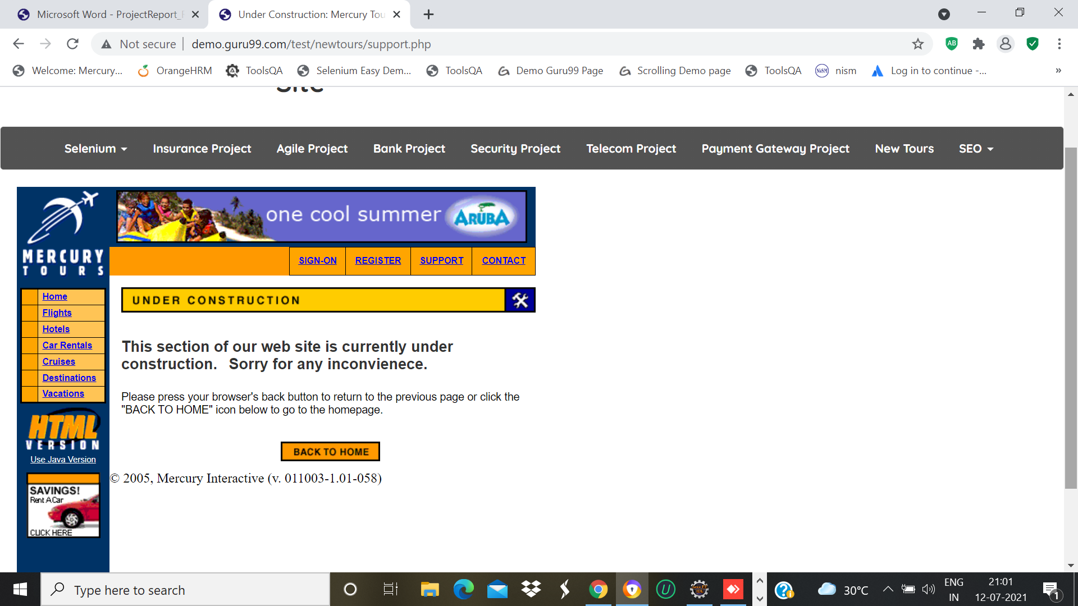

w.findElement(By.*linkText*("Hotels")).click();

Thread.*sleep*(3000);

w.navigate().back();

System.***out***.println("hotels");

Thread.*sleep*(5000);

TC_11-To check the Functionality of Car rental page

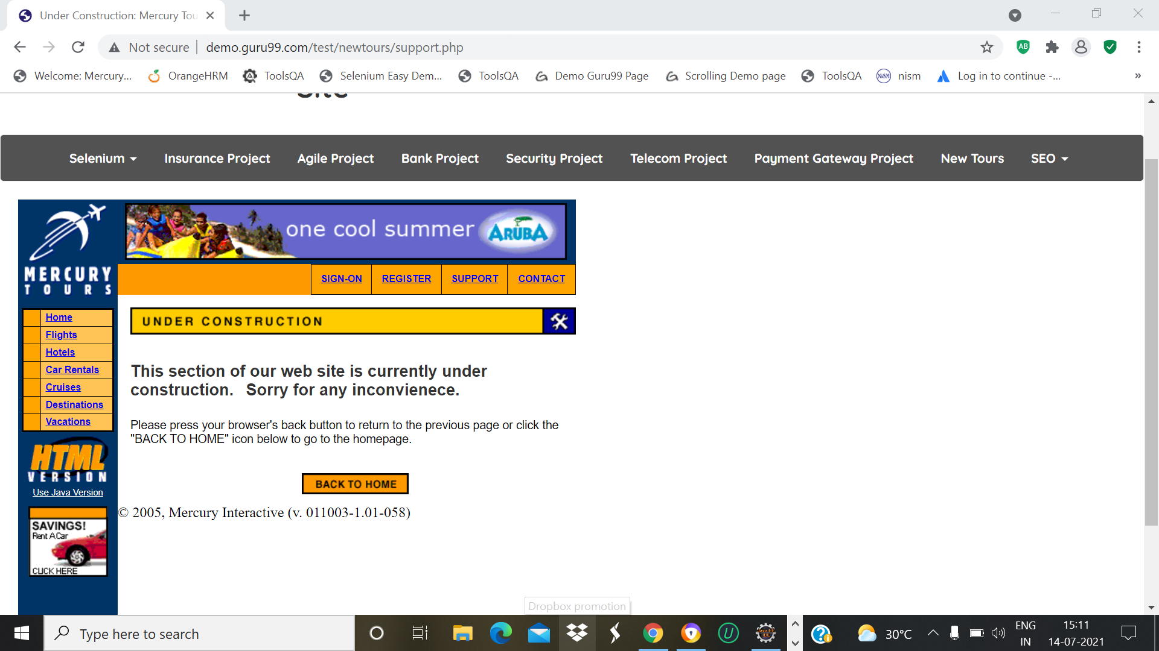

w.findElement(By.*linkText*("Car Rentals")).click();

Thread.*sleep*(2000);

w.navigate().back();

System.***out***.println("car rentals");

Thread.*sleep*(2000);

TC_12-To check the Functionality of Cruises page



w.findElement(By.*linkText*("Cruises")).click();

Thread.*sleep*(2000);

System.***out***.println("Cruises");

TC_13-To check the Functionality of Destinations page

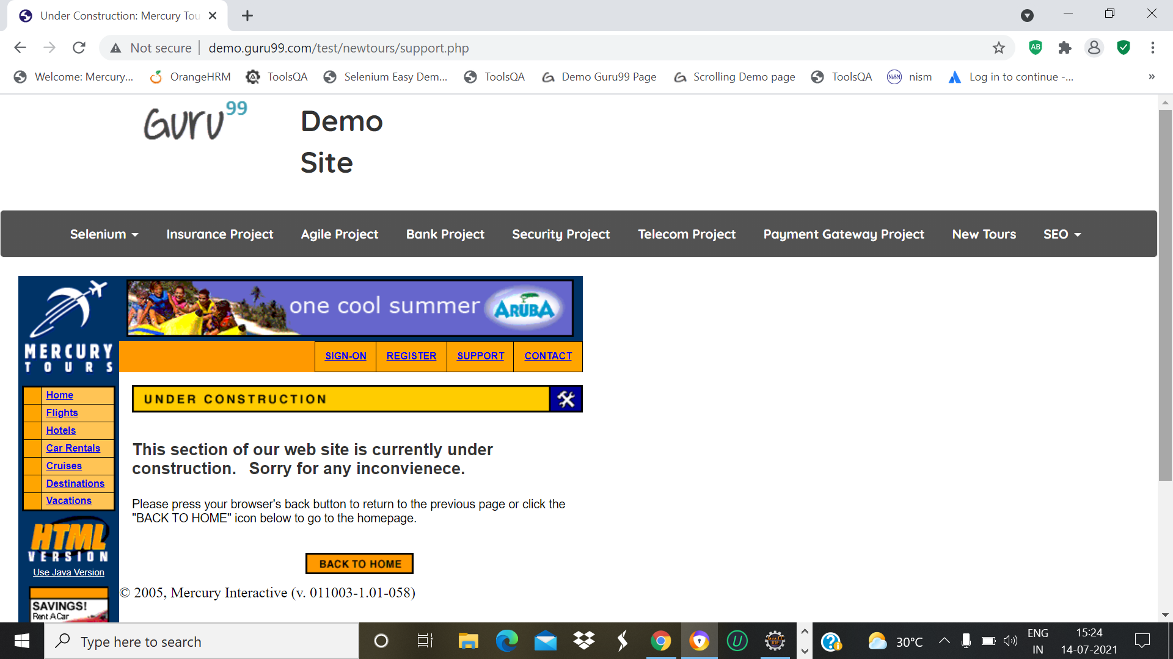

w.findElement(By.*linkText*("Destinations")).click();

Thread.*sleep*(2000);

w.navigate().back();

System.***out***.println("Destinations");

Thread.*sleep*(2000);

TC_14-To check the Functionality of Vacations page

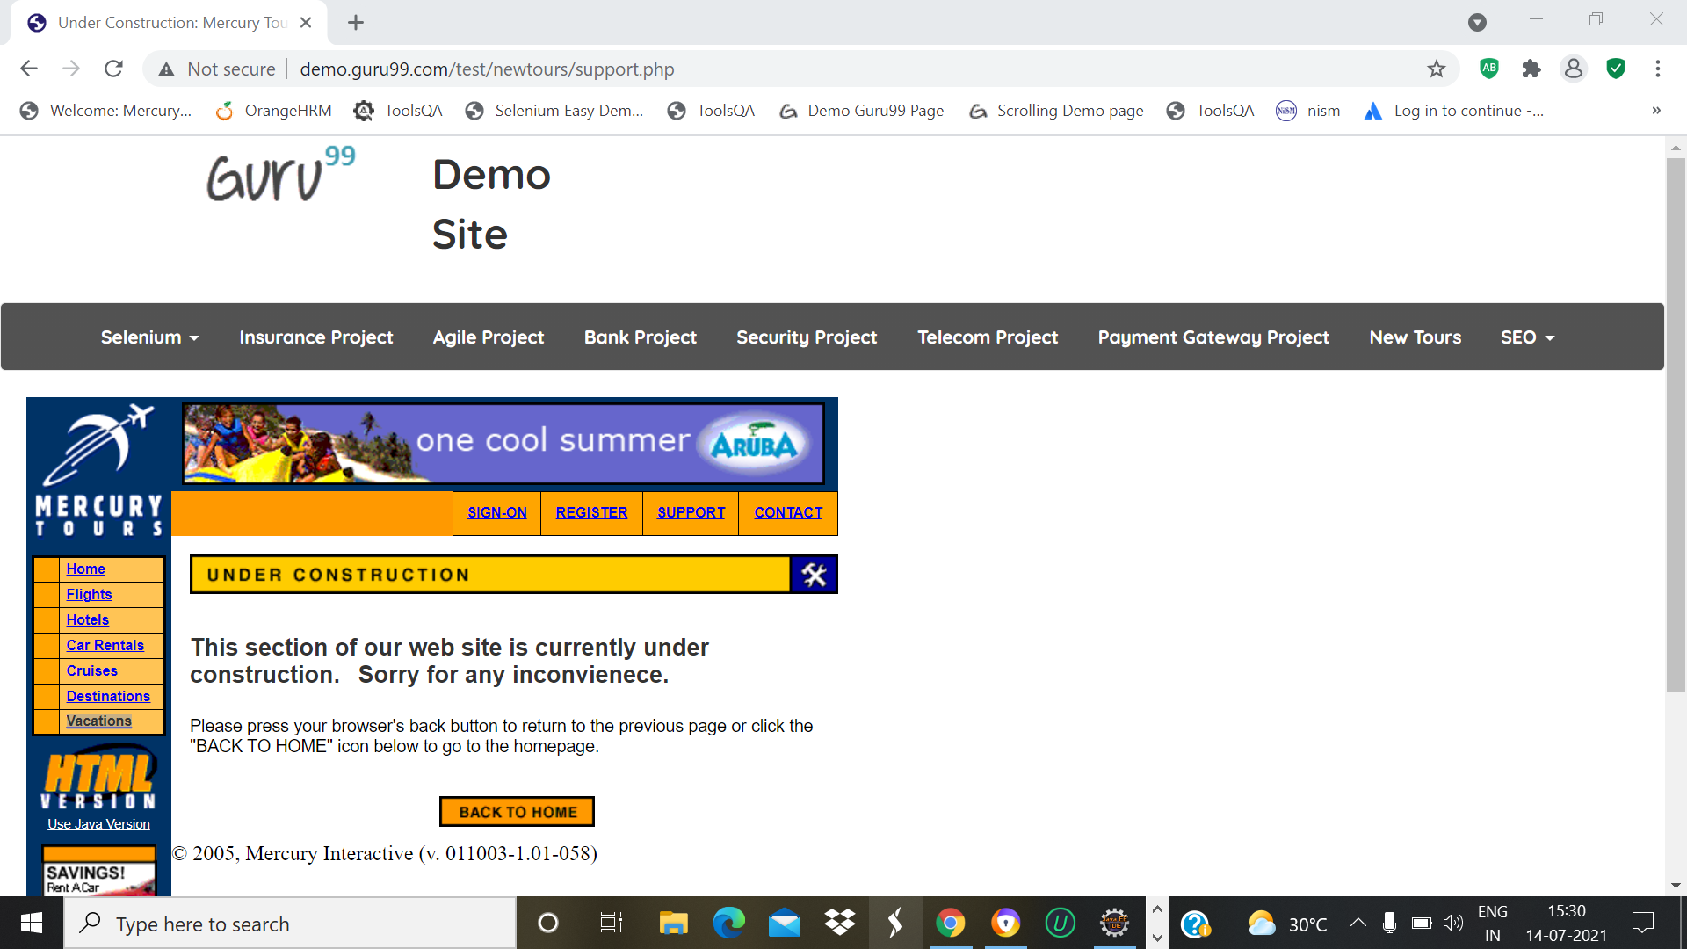

w.findElement(By.*linkText*("Vacations")).click();

Thread.*sleep*(2000);

w.navigate().back();

System.***out***.println("vacations");

Thread.*sleep*(2000);

TC_15-To check the Functionality of Selenium page

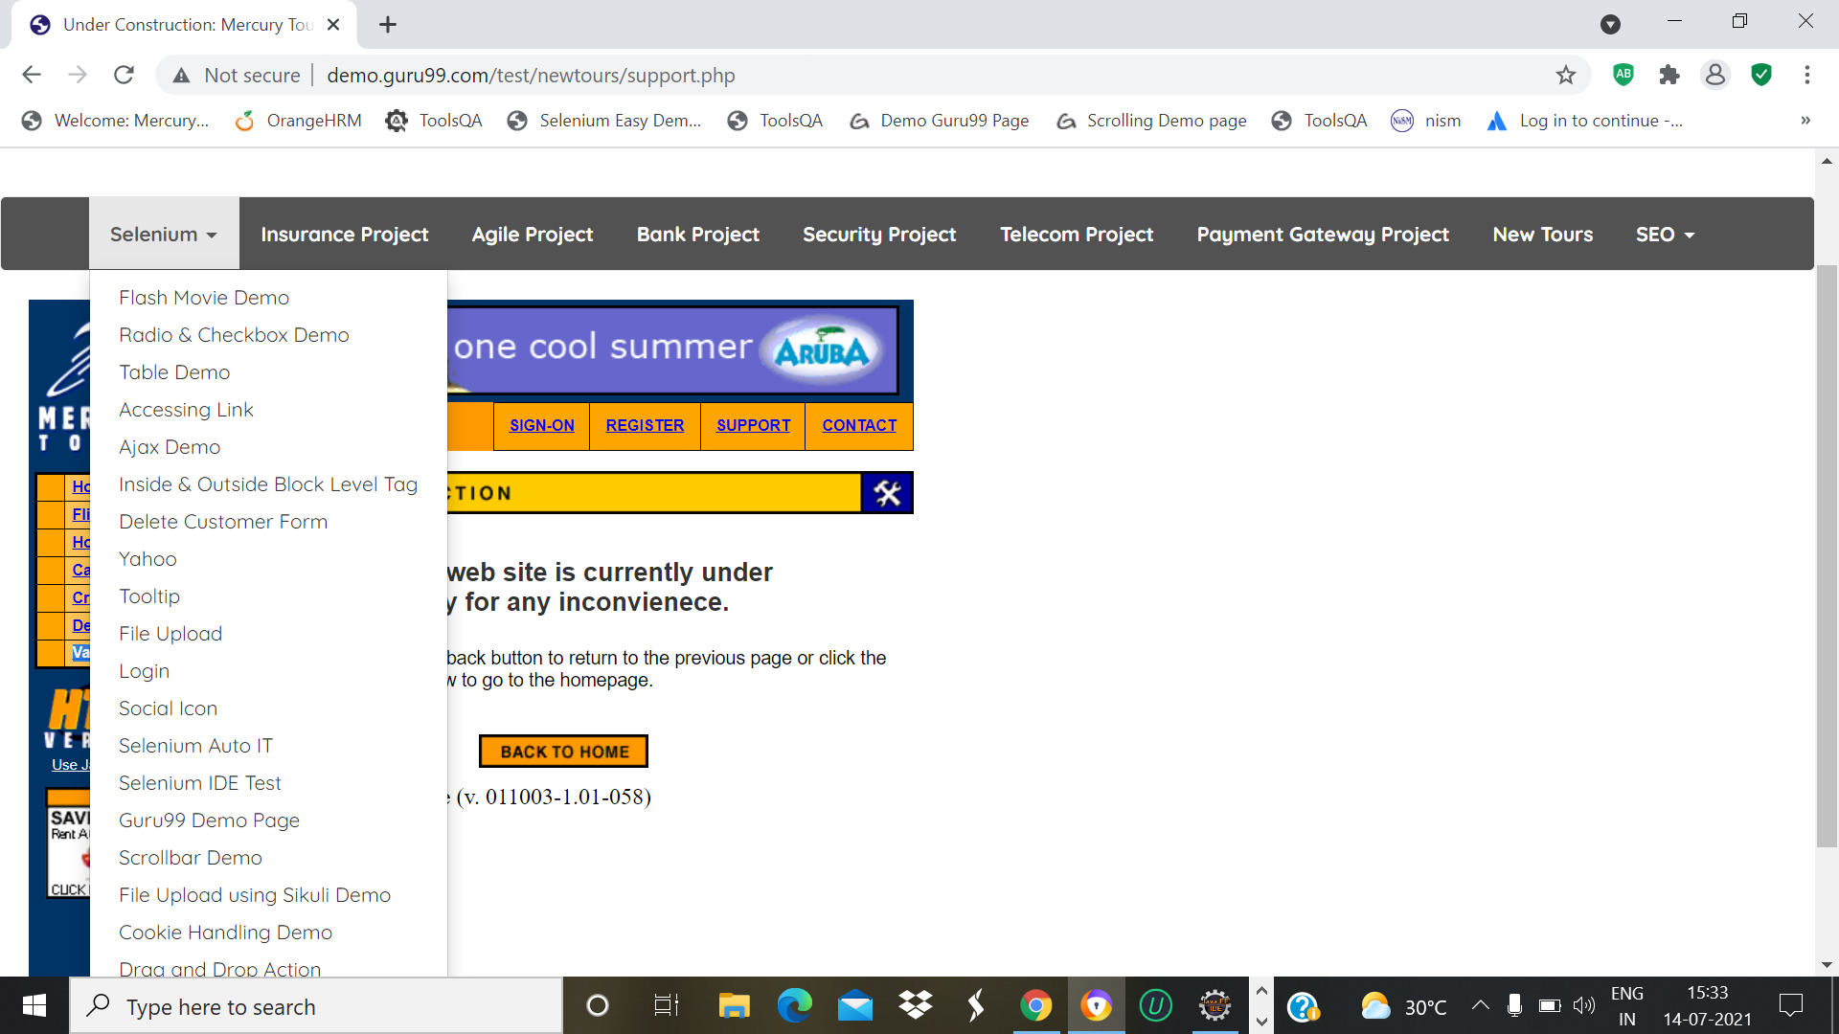

w.findElement(By.*partialLinkText*("Seleni")).click();

Thread.*sleep*(2000);

TC_16-To check the Functionality of Flash Movie Demo in Selenium page

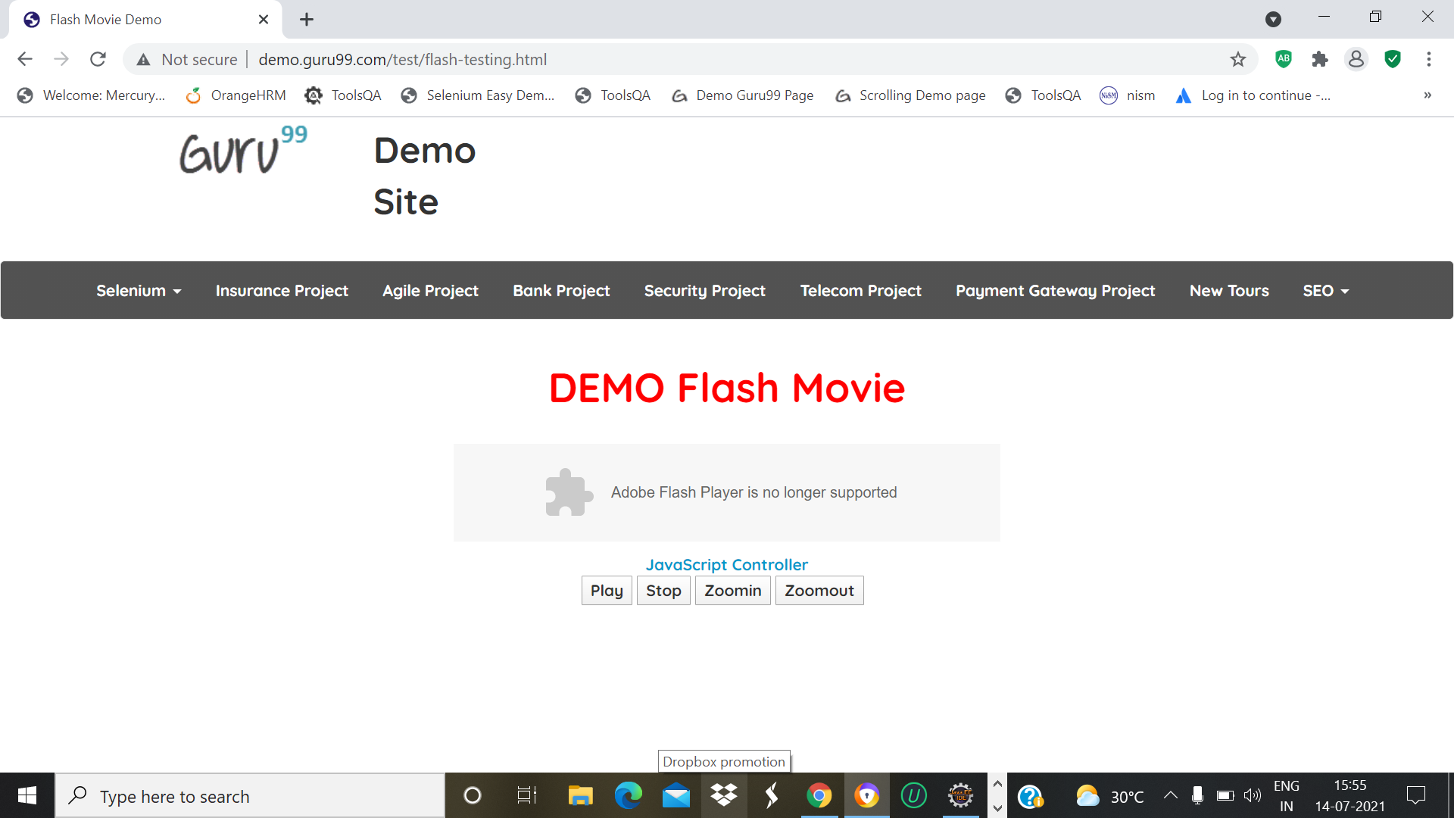

w.findElement(By.*linkText*("Flash Movie Demo")).click();

w.findElement(By.name("Play")).click();

Thread.*sleep*(1000);

DEFECT:Play button is not working properly

TC_17-To check the Functionality of Radio & Checkbox Demo in Selenium page

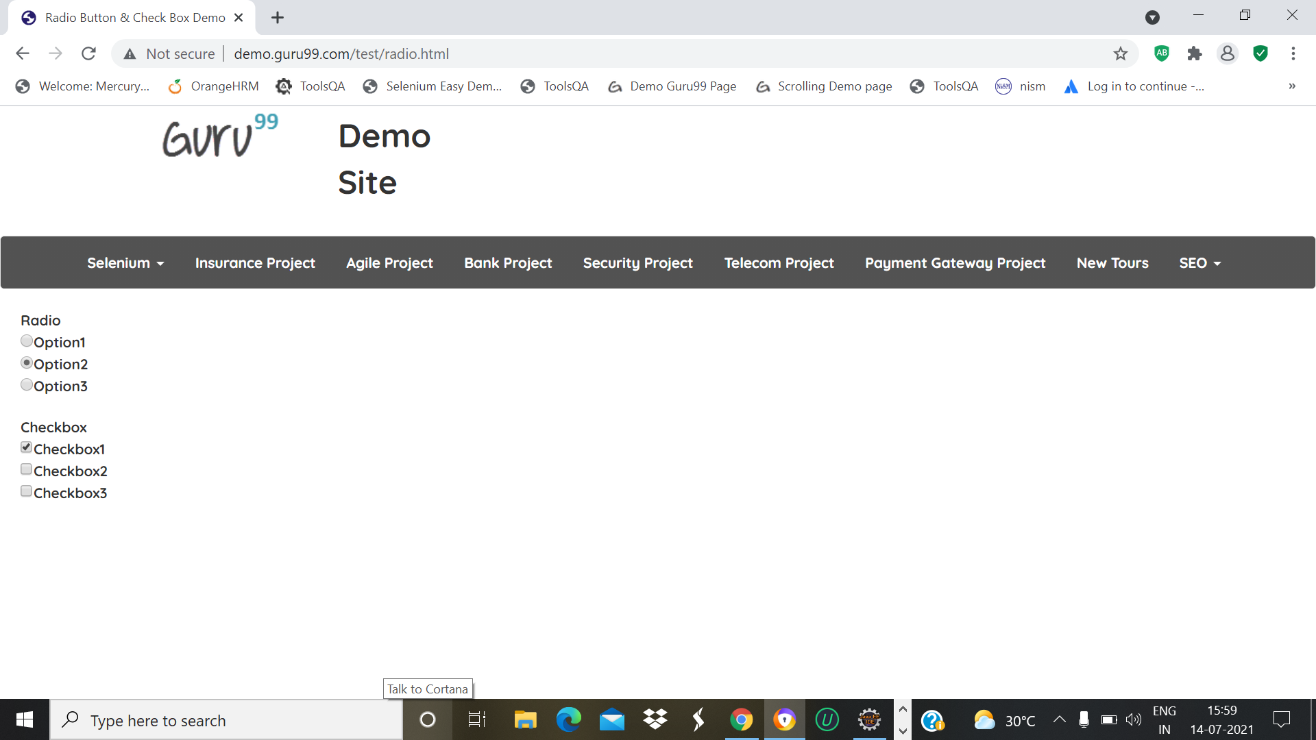

w.findElement(By.*linkText*("Radio & Checkbox Demo")).click();

Thread.*sleep*(2000);

w.findElement(By.*xpath*("//*[@id=\"vfb-7-2\"]")).click();

Thread.*sleep*(2000);

w.findElement(By.*xpath*("//*[@id=\"vfb-6-0\"]")).click();

w.navigate().back();

TC_18-To check the Functionality of Table Demo in Selenium page

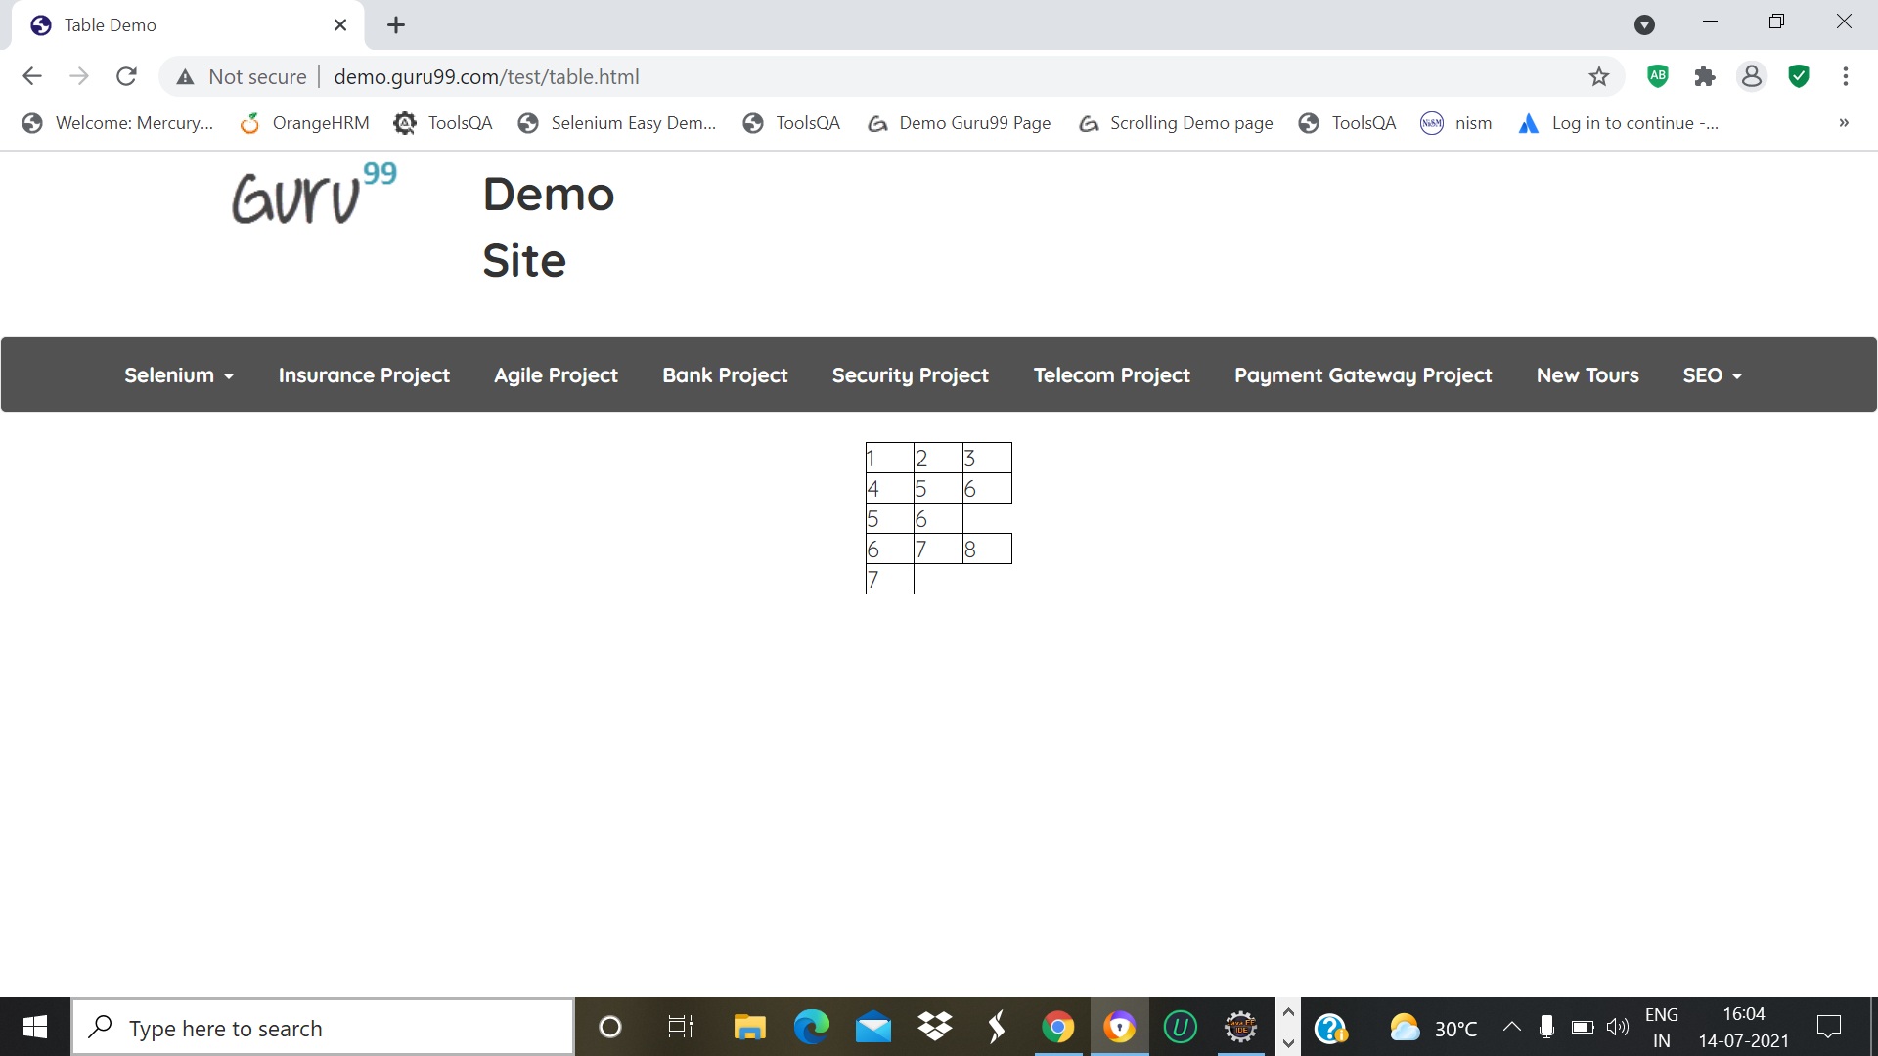

w.findElement(By.*linkText*("Table Demo")).click();

Thread.*sleep*(2000);

w.navigate().back();

TC_19-To check the Functionality of Accessing Link Demo in Selenium page

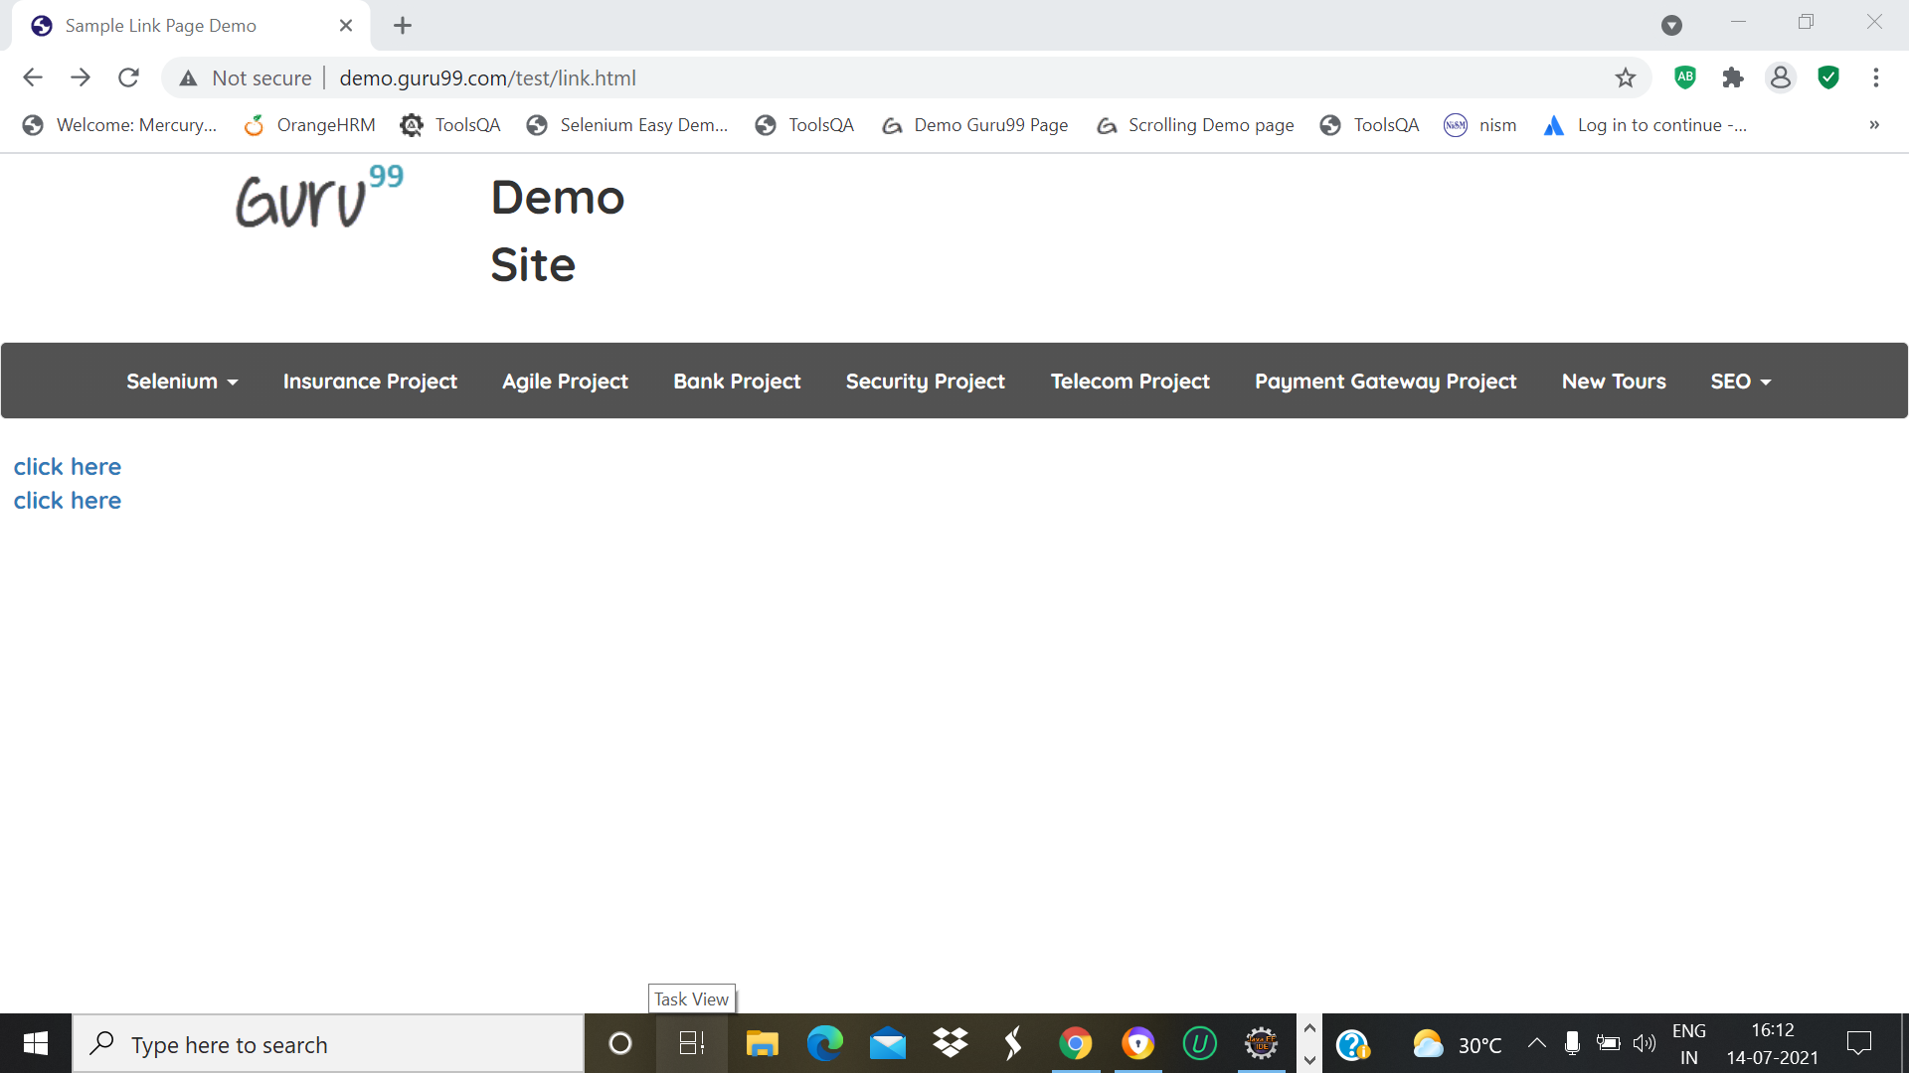

w.findElement(By.*linkText*("Accessing Link")).click();

w.findElement(By.*linkText*("click here")).click();

Thread.*sleep*(2000);

w.navigate().back();

w.navigate().back();

TC_20-To Open the webpage of Accessing Link Demo in Selenium page

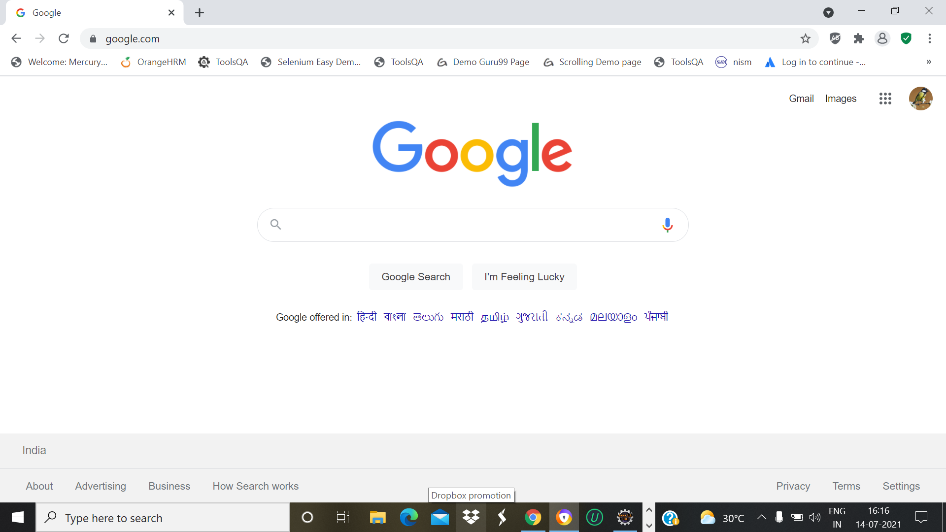

TC_21-To check the Functionality of Ajax Demo in Selenium page

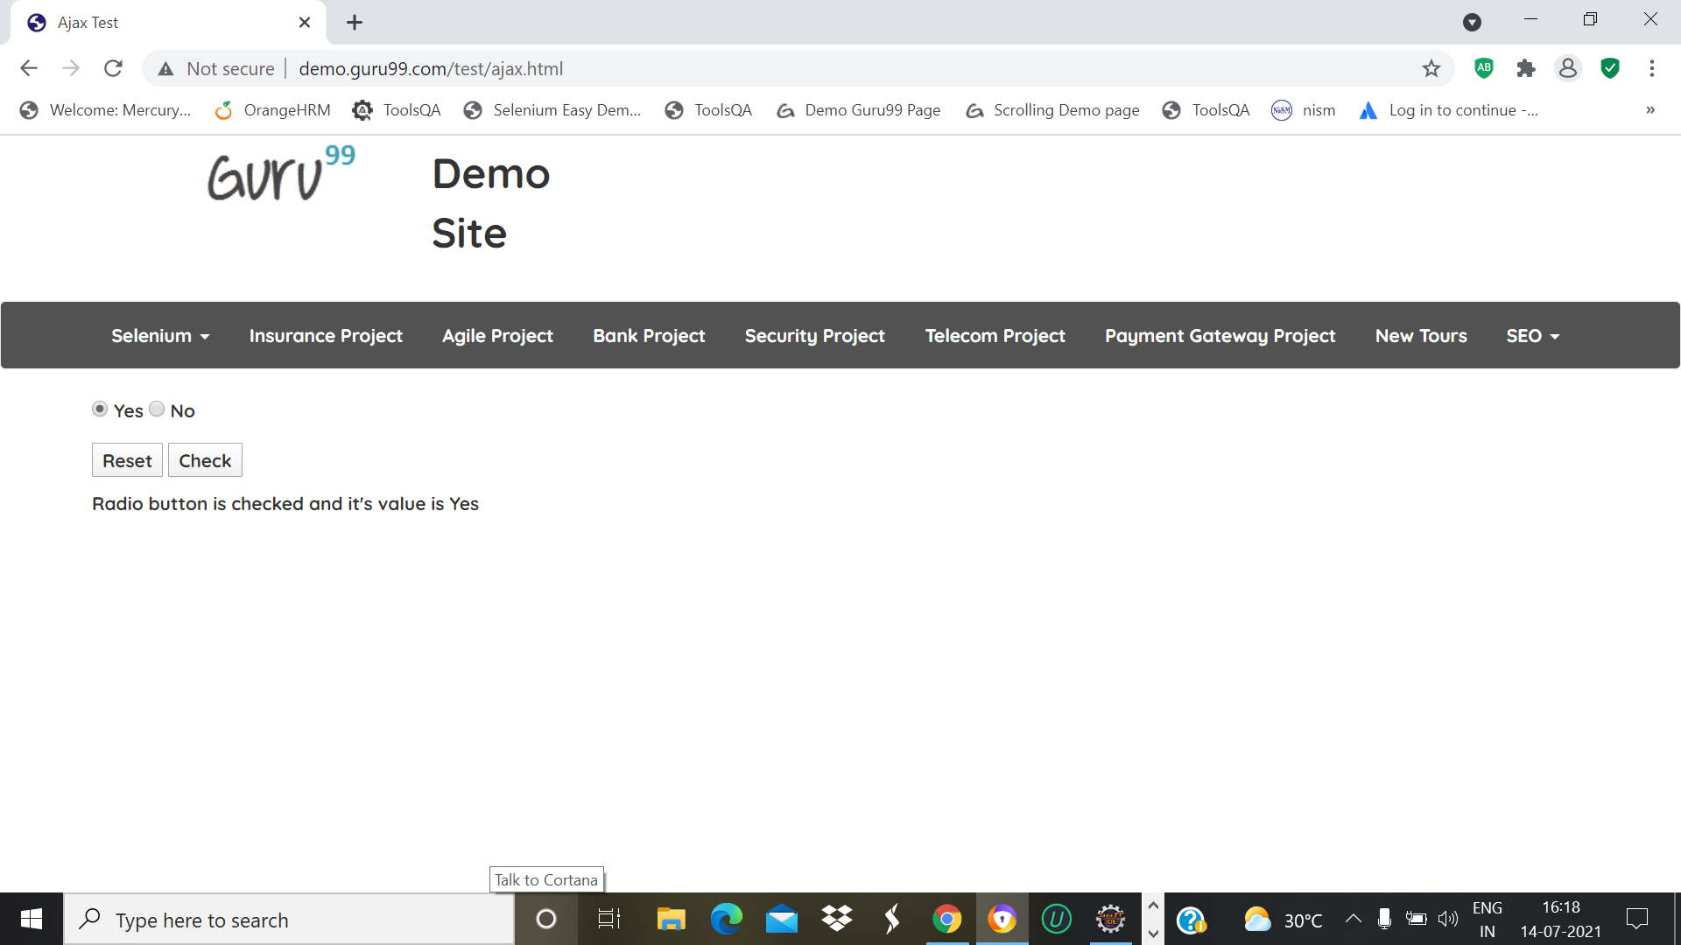

w.findElement(By.*linkText*("Ajax Demo")).click();

Thread.*sleep*(2000);

w.findElement(By.*name*("name")).click();

w.findElement(By.*id*("buttoncheck")).click();

Thread.*sleep*(2000);

w.navigate().back();

TC_22-To check the Functionality of Inside & Outside Block Level Tag in Selenium page

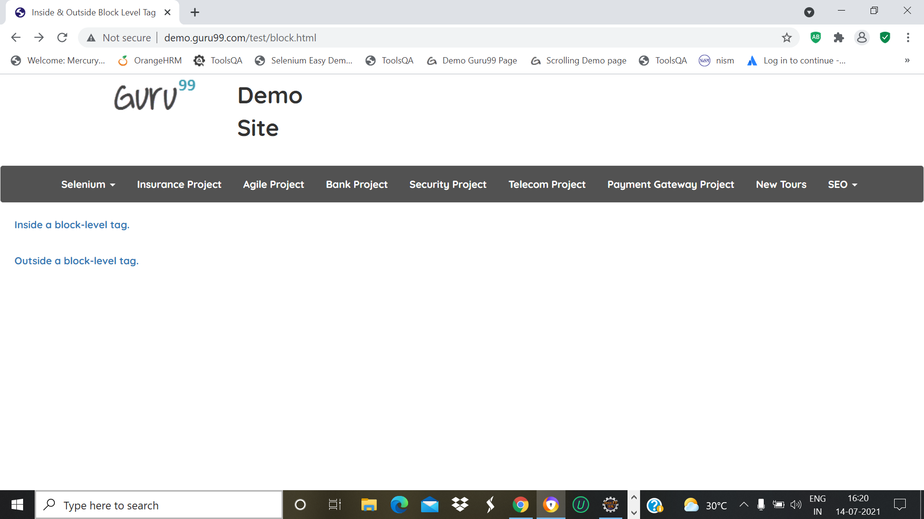

w.findElement(By.*xpath*("//*[@id=\"navbar-brand

centered\"]/ul/li[1]/ul/li[6]/a")).click();

w.findElement(By.*xpath*("/html/body/p/a")).click();

Thread.*sleep*(2000);

w.navigate().back();

TC_23-To check the Functionality of Inside Block Level Tag in Selenium page

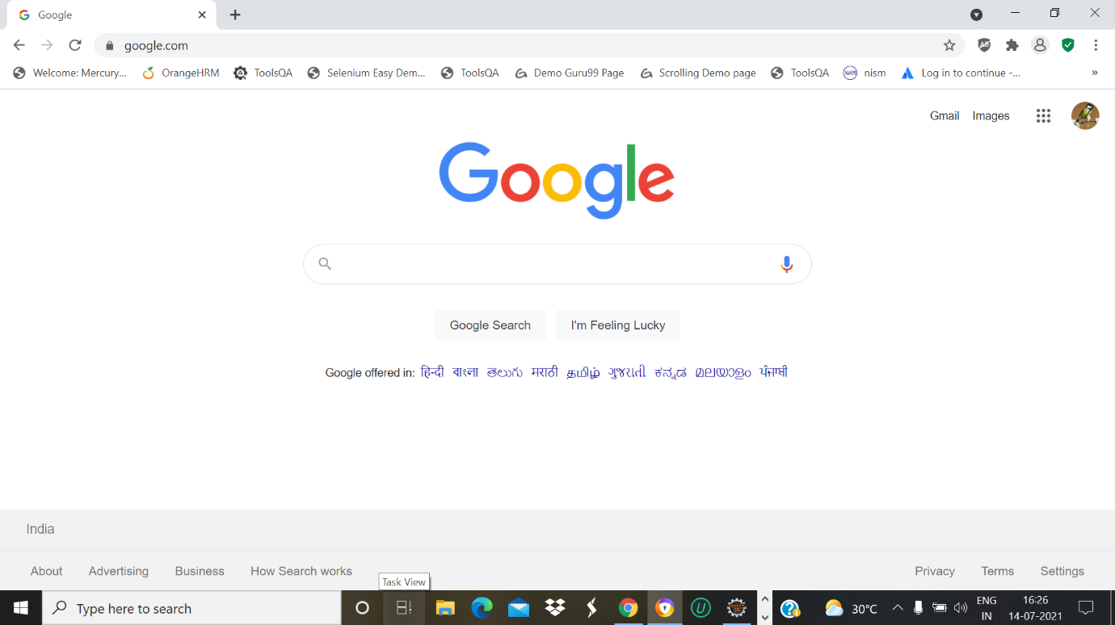

TC_24-To check the Functionality of Delete Customer Form in Selenium page

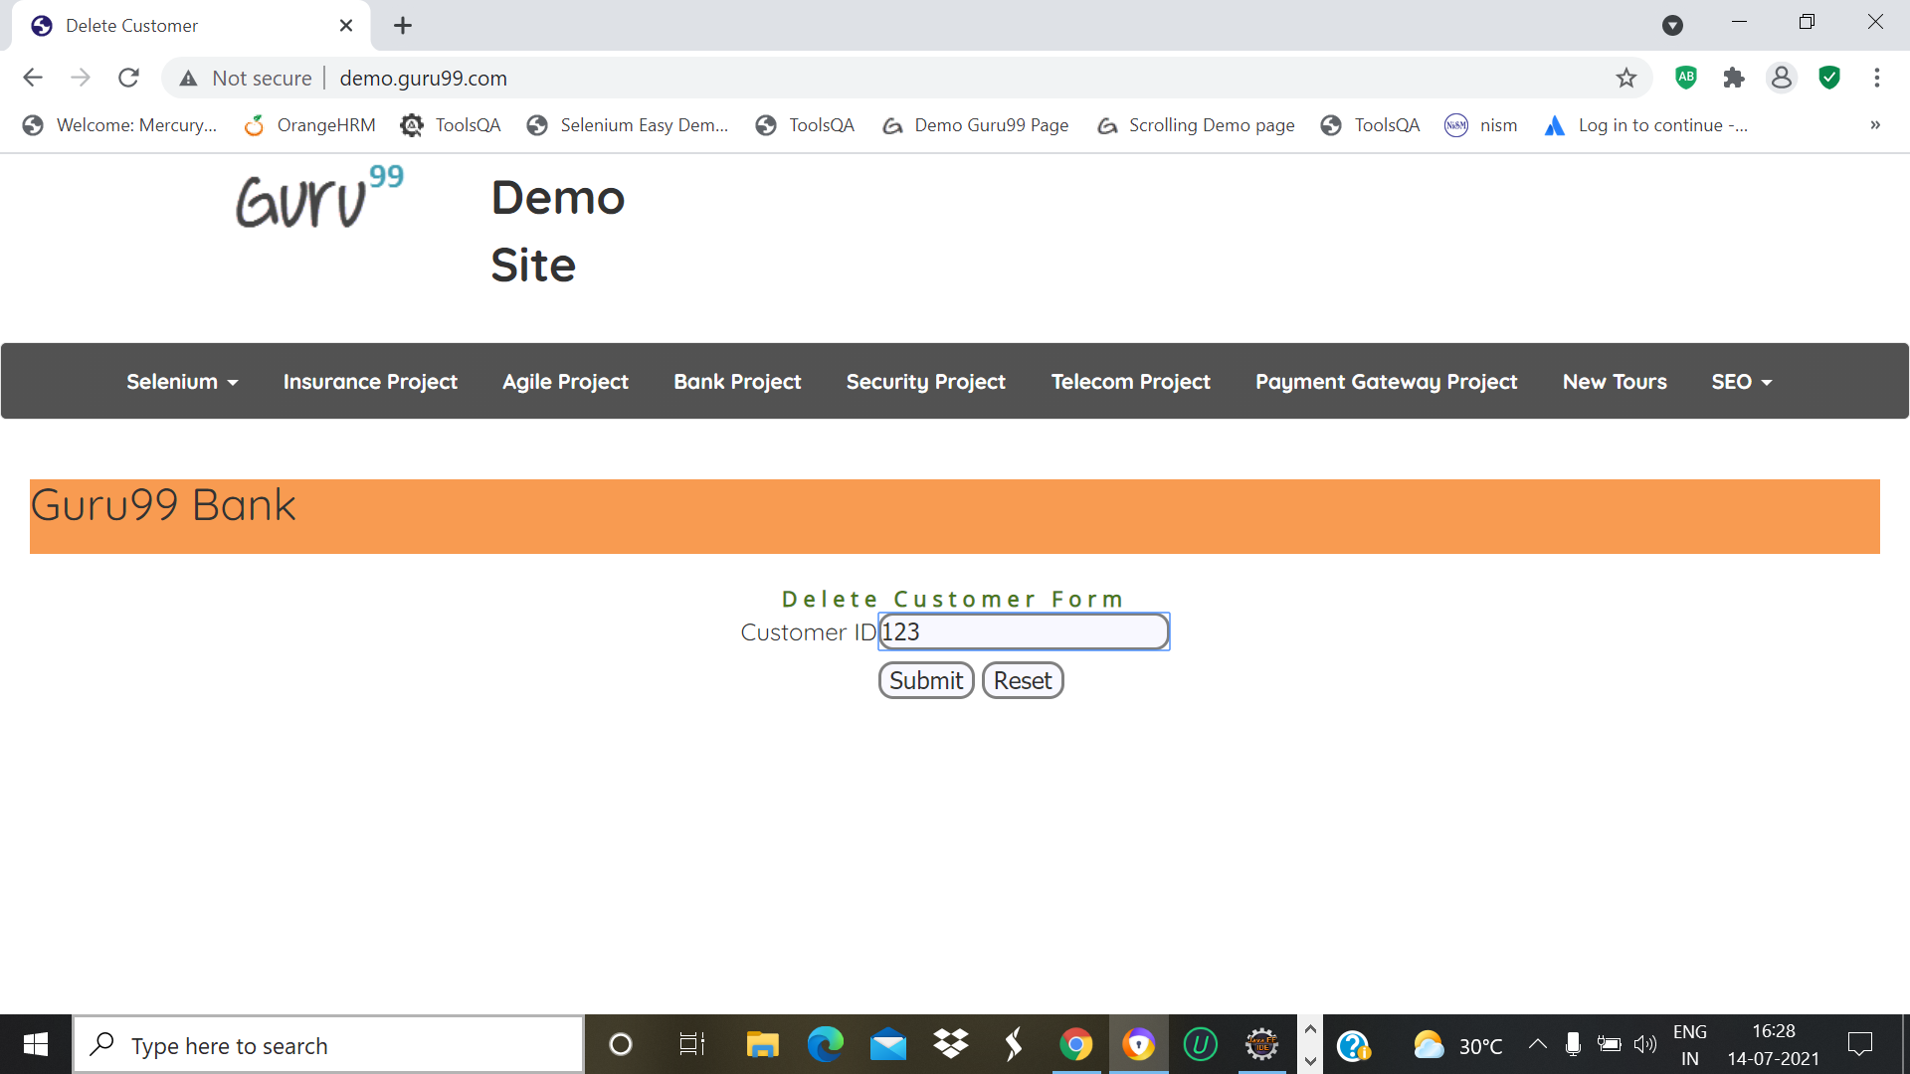

w.findElement(By.*xpath*("//*[@id=\"navbar-brand-centered\"]/ul/li[1]/ul/li[7]/a")).click();

w.findElement(By.name("cusid")).sendKeys("123");

w.findElement(By.name("submit")).click();

Thread.*sleep*(2000);

w.navigate().back();

TC_25-To check the Functionality of yahoo in Selenium page

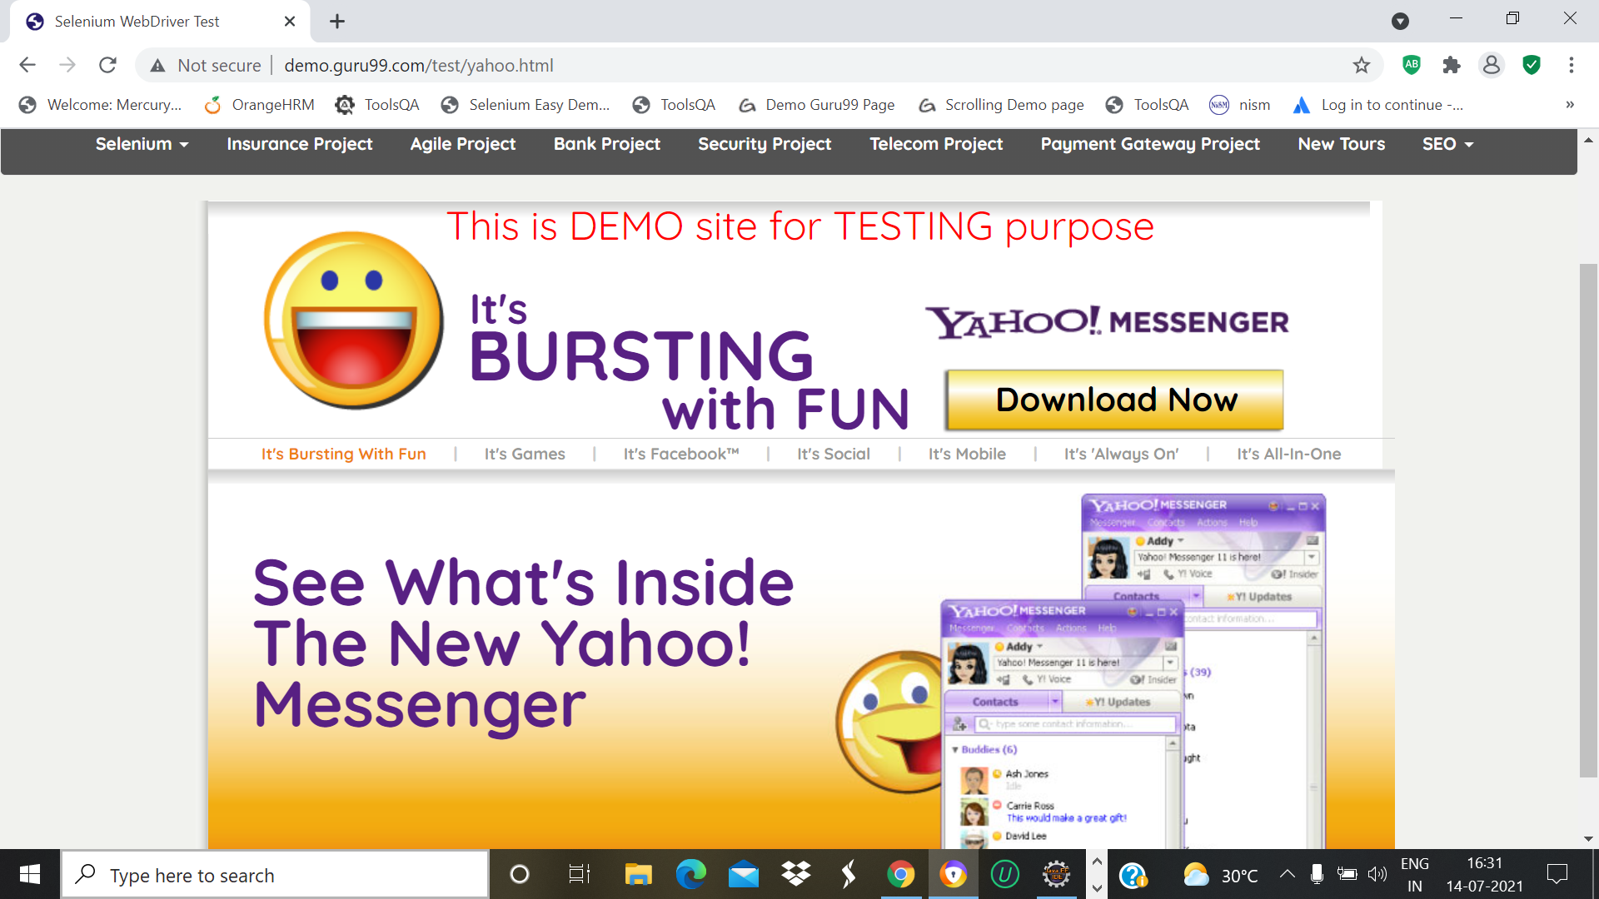

w.findElement(By.*xpath*("//*[@id=\"navbar-brand-centered\"]/ul/li[1]/ul/li[8]/a")).click();

Thread.*sleep*(2000);

w.findElement(By.xpath("//*[@id=\"messenger-download\"]")).click();

w.navigate().back();

TC_26-To check the Functionality of Tooltip in Selenium page

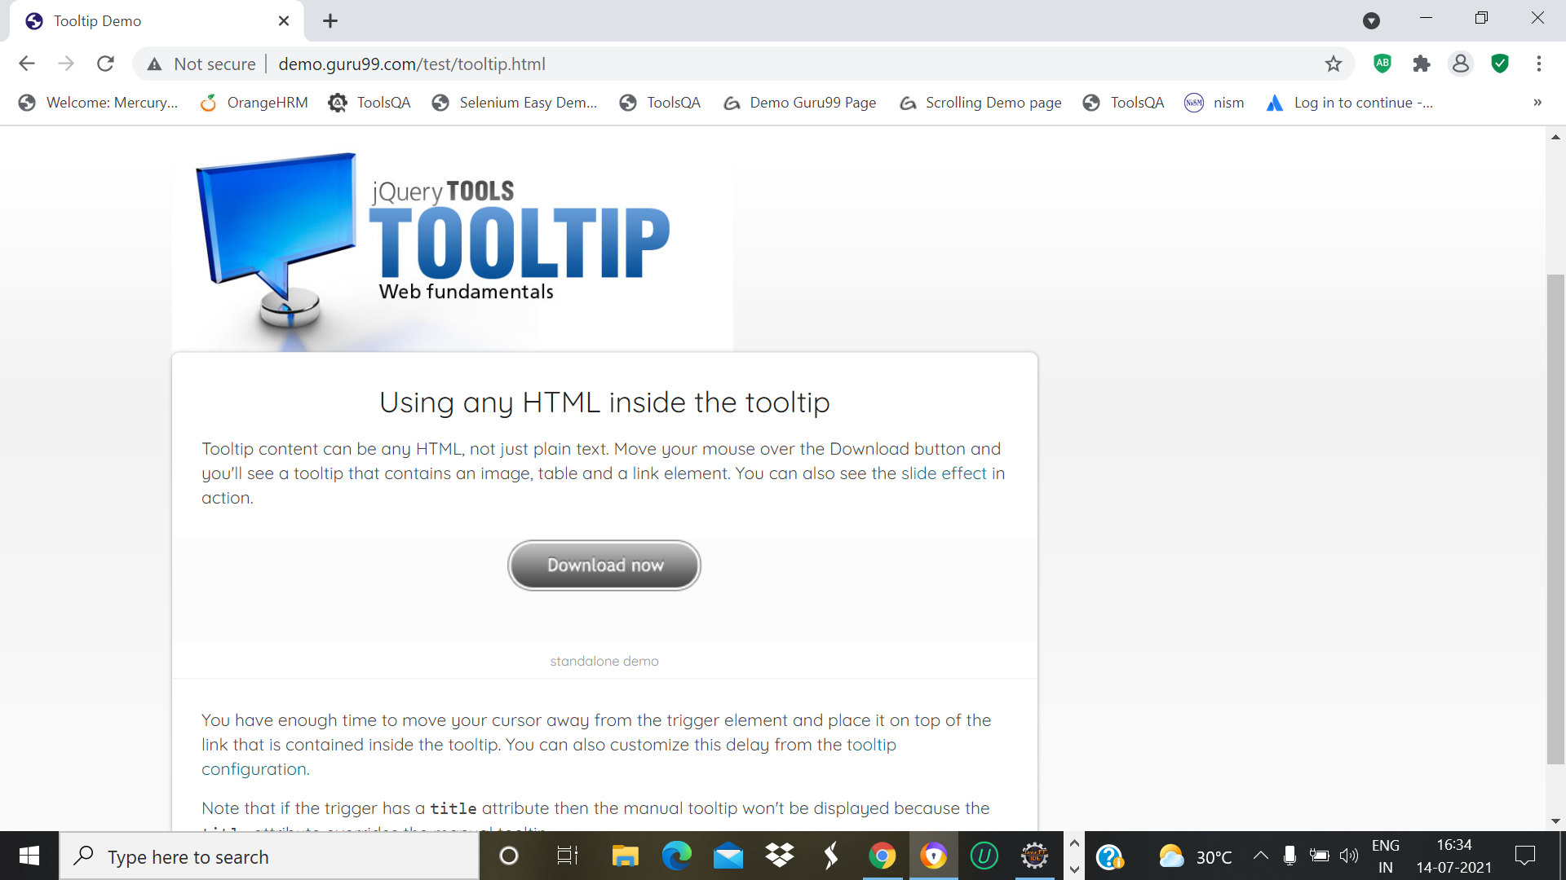

w.findElement(By.*xpath*("//*[@id=\"navbar-brand-centered\"]/ul/li[1]/ul/li[9]/a")).click();

Thread.*sleep*(2000);

w.findElement(By.xpath("//*[@id=\"download_now\"]")).click();

w.navigate().back();

TC_27-To check the Functionality of File Upload in Selenium page

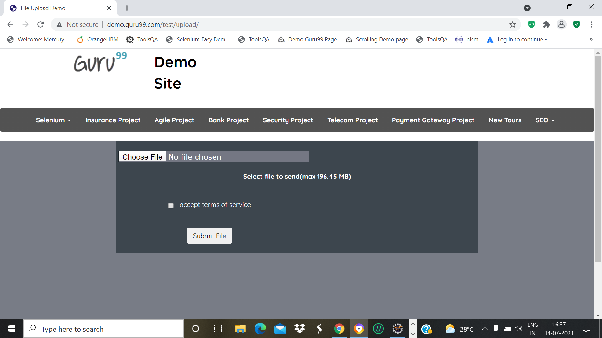

w.findElement(By.*xpath*("//*[@id=\"navbar-brand-centered\"]/ul/li[1]/ul/li[10]/a")).click();

w.findElement(By.*name*("uploadfile_0")).sendKeys("C:\\Users\\win 10\\Desktop\\New.txt");

Thread.*sleep*(2000);

w.findElement(By.*name*("send")).click();

Thread.*sleep*(2000);

w.navigate().back();

w.navigate().back();

TC_28-To check the Functionality of Login in Selenium page

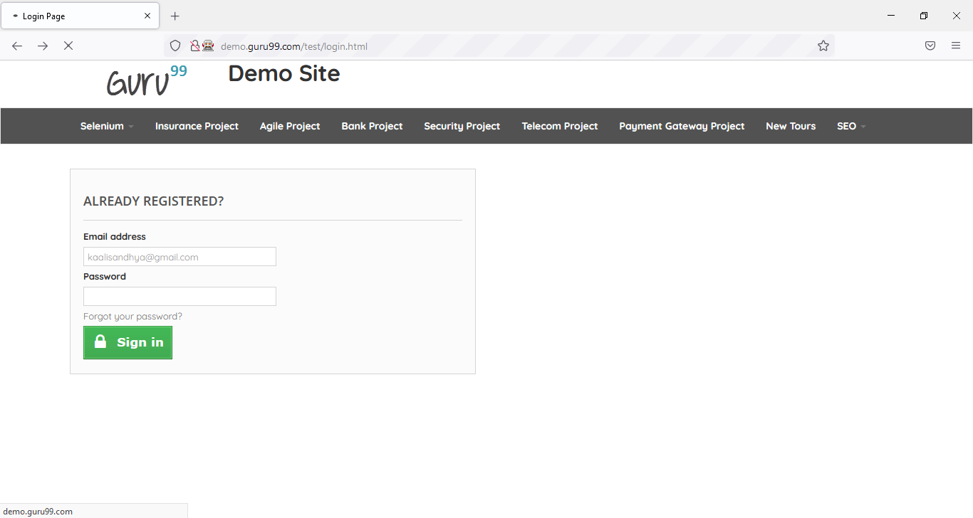

w.findElement(By.*xpath*("//*[@id=\"navbar-brand-centered\"]/ul/li[1]/ul/li[11]/a")).click();

Thread.*sleep*(2000);

w.findElement(By.*name*("email")).sendKeys("kaalisandhya24@gmail.com");

w.findElement(By.*name*("passwd")).sendKeys("123456");

w.findElement(By.*xpath*("//*[@id=\"SubmitLogin\"]/span")).click();

w.navigate().back();

TC_29-Open the Login page after sign-in Selenium page

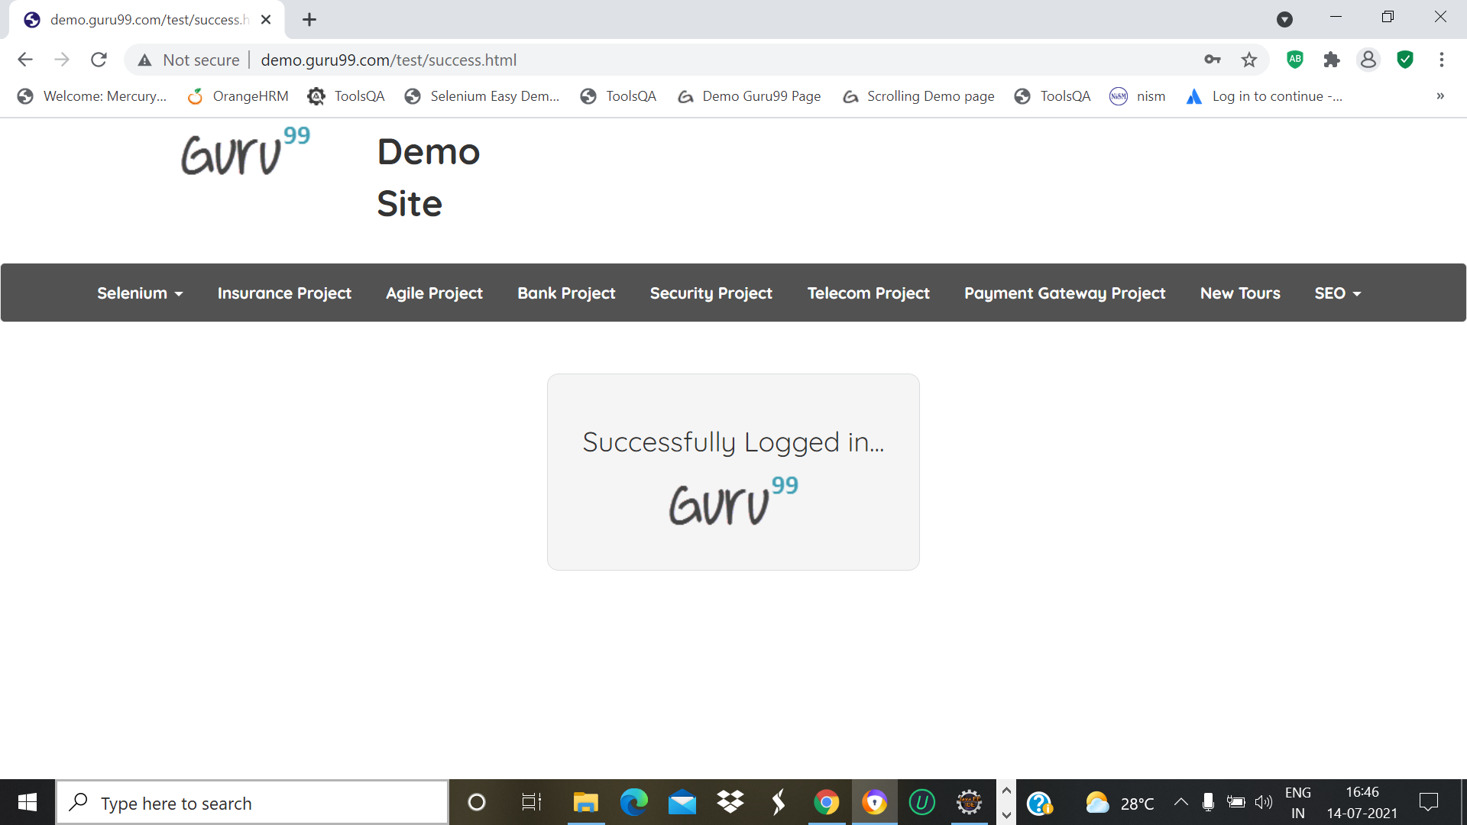

w.navigate().back();

TC_30-To check the Functionality of Social icon in Selenium page

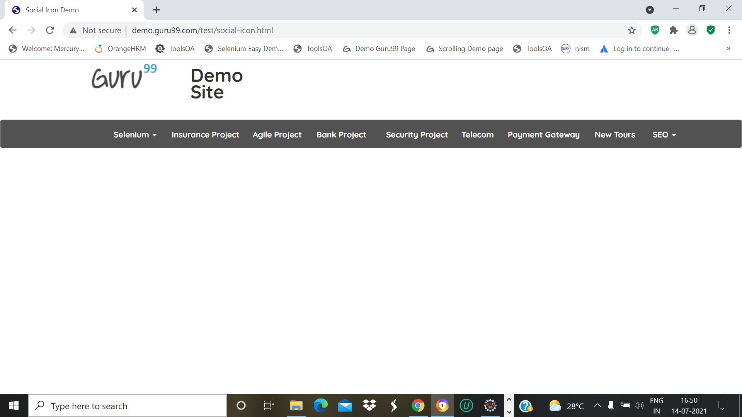

w.findElement(By.*xpath*("//*[@id=\"navbar-brand- centered\"]/ul/li[1]/ul/li[12]/a")).click();

Thread.*sleep*(2000);

w.navigate().back();

TC_31-To check the Functionality of Selenium Auto IT in Selenium page

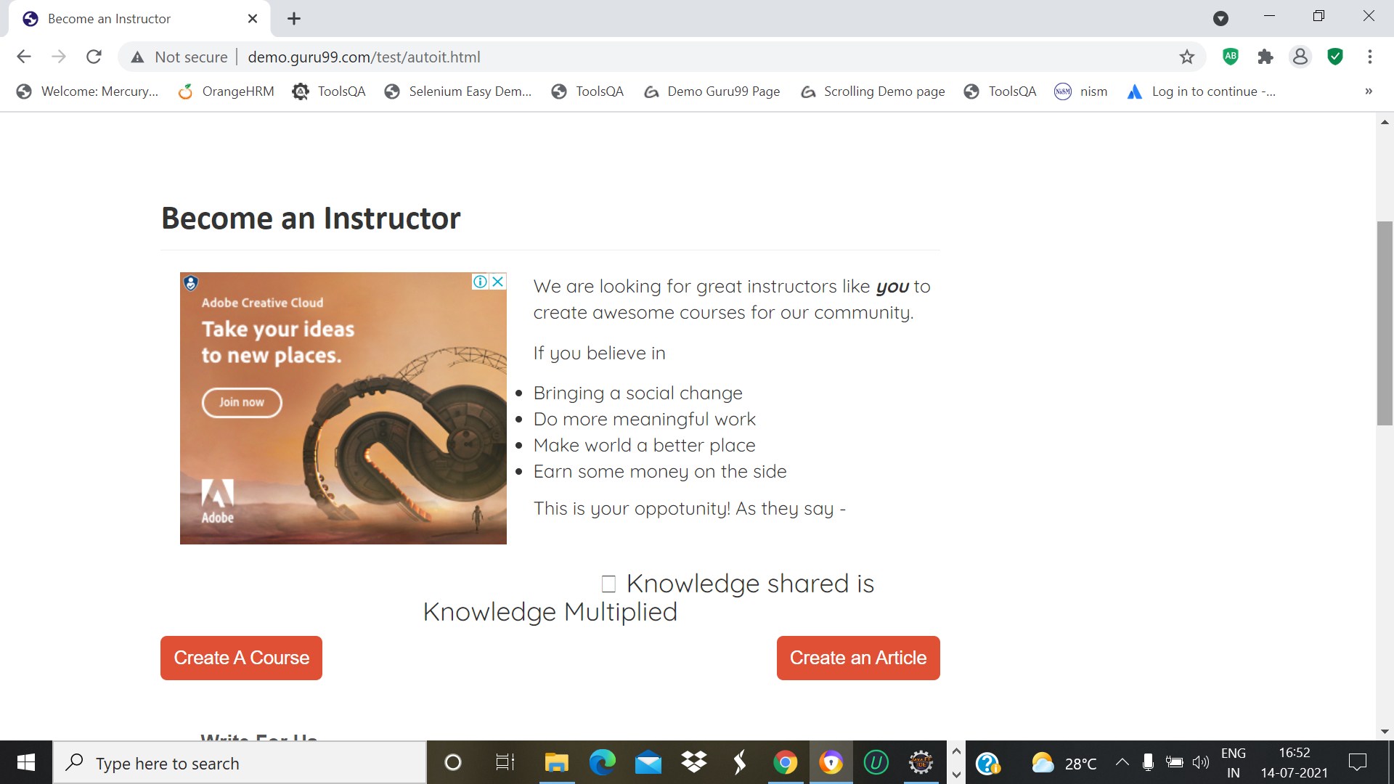

w.findElement(By.*xpath*("//*[@id=\"navbar-brand-centered\"]/ul/li[1]/ul/li[13]/a")).click();

Thread.*sleep*(2000);

w.manage().window().maximize();

JavascriptExecutor js =(JavascriptExecutor) w;

js.executeScript("window.scrollTo(0,2000)");

Thread.*sleep*(3000);

js.executeScript("window.scrollBy(0,-2000)");

w.navigate().back();

TC_32-To check the Functionality of Selenium IDE Test in Selenium page

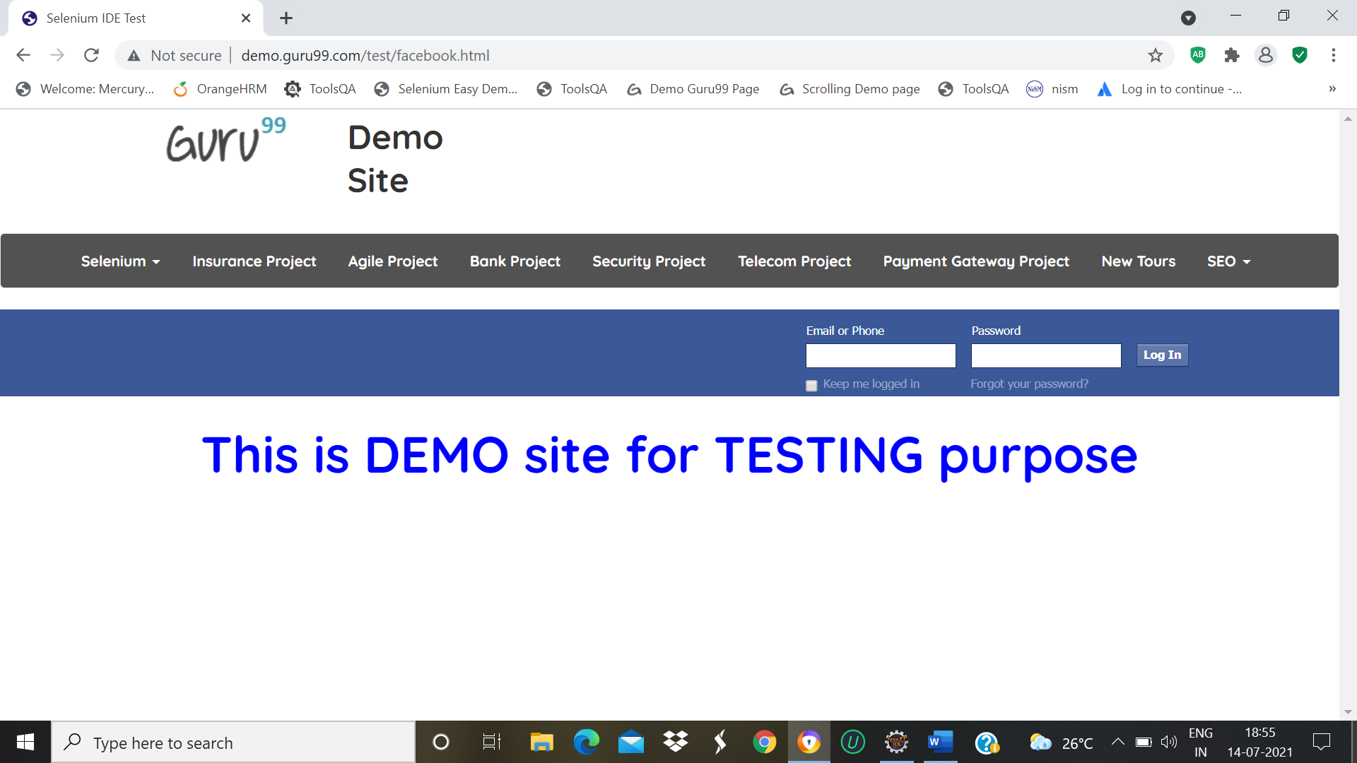

w.findElement(By.*xpath*("//*[@id=\"navbar-brand-centered\"]/ul/li[1]/ul/li[14]/a")).click();

Thread.*sleep*(2000);

w.navigate().back();

TC_33-To check the Functionality of Guru99 Demo in Selenium page

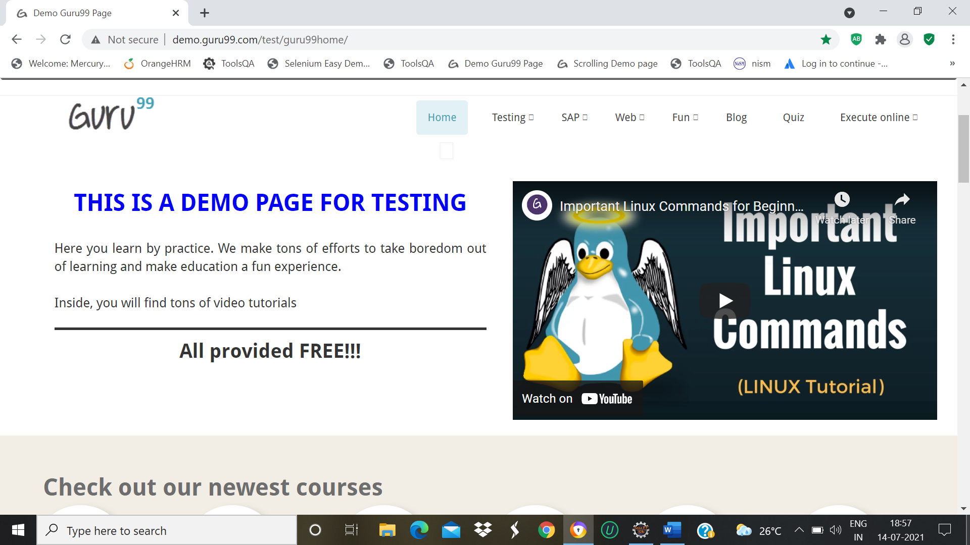

w.findElement(By.*xpath*("//*[@id=\"navbar-brand-centered\"]/ul/li[1]/ul/li[15]/a")).click();

Thread.*sleep*(2000);

w.navigate().back();

TC_34-To check the Functionality of Scroll bar Demo in Selenium page

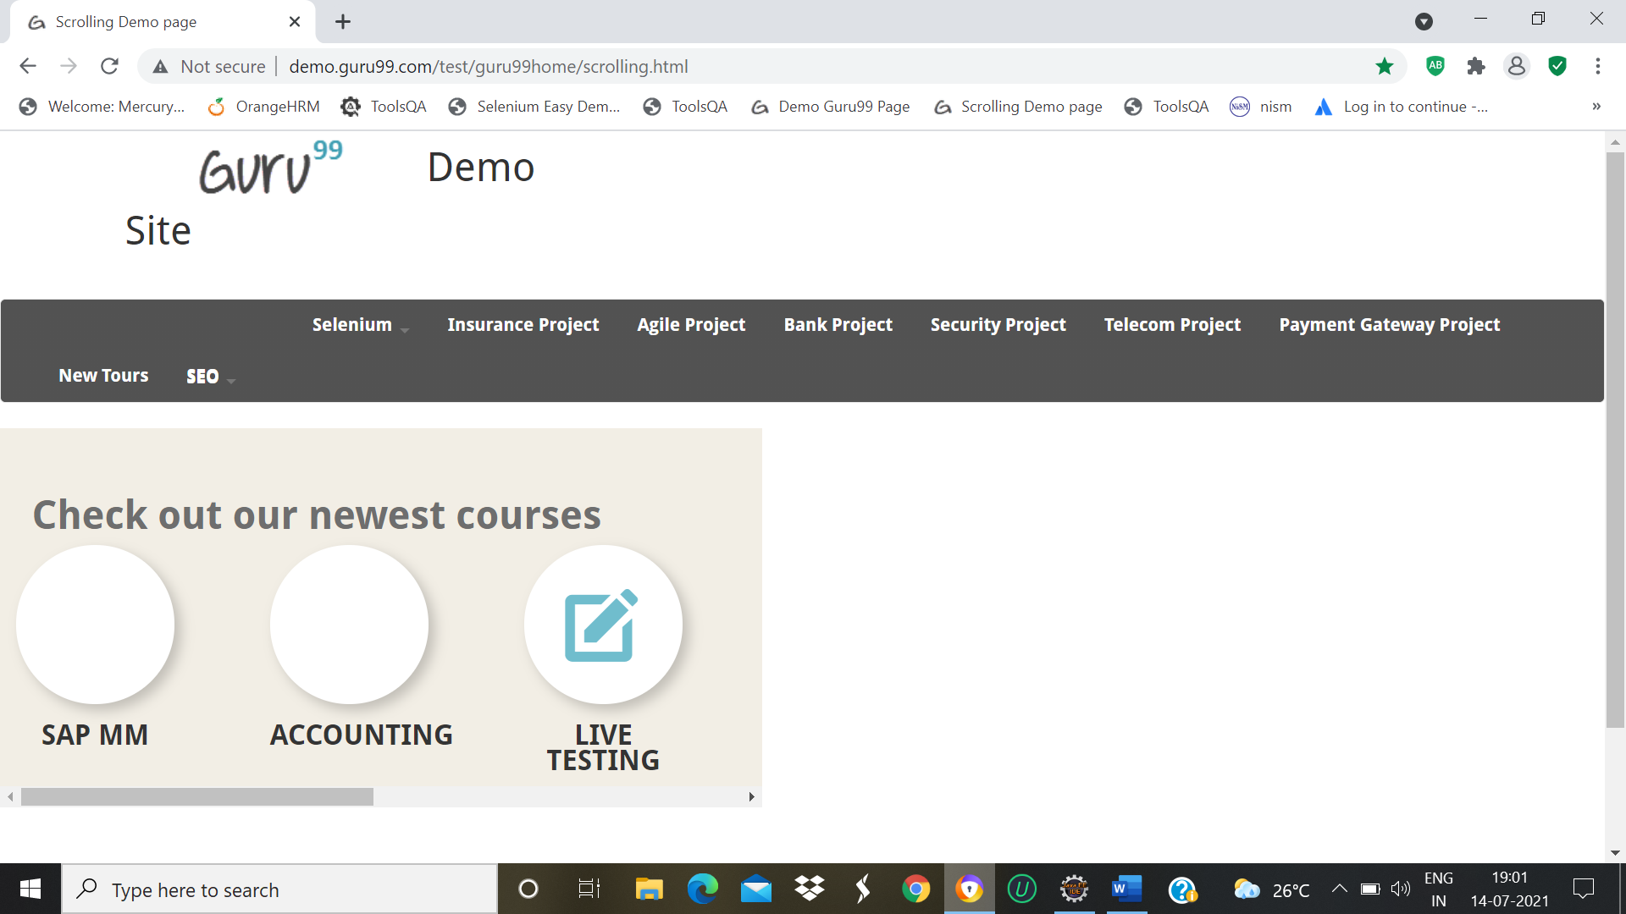

w.findElement(By.*xpath*("//*[@id=\"navbar-brand-centered\"]/ul/li[1]/ul/li[16]/a")).click();

Thread.*sleep*(2000);

w.manage().window().maximize();

WebElement Element = w.findElement(By.*xpath*("//*[@id=\"rt-feature\"]/div/div[1]/div/div/div/div/div[6]/div/div/div/div/div[1]/div/div/a/i"));

JavascriptExecutor js1 =(JavascriptExecutor) w;

js1.executeScript("arguments[0].scrollIntoView();",Element);

w.navigate().back();

TC_35-To check the Functionality of Fileupload Using Sikuli Demo in Selenium page

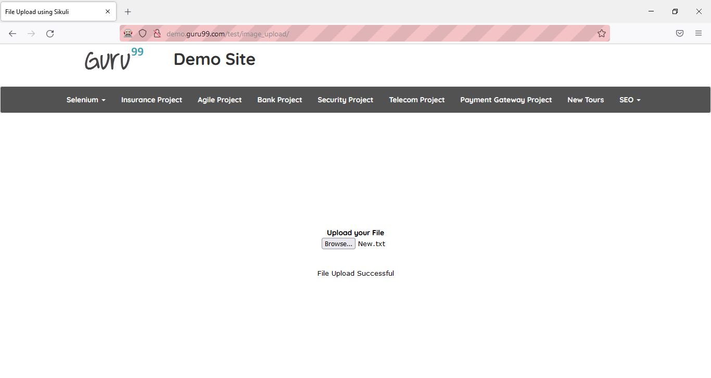

w.findElement(By.*xpath*("//*[@id=\"navbar-brand-centered\"]/ul/li[1]/ul/li[17]/a")).click();

w.findElement(By.*xpath*("//*[@id=\"photoimg\"]")).sendKeys("C:\\\\Users\\\\jhansi\\\\Desktop\\\\Selenium_book1 (1).pdf");

Thread.*sleep*(2000);

w.navigate().back();

TC_36-To check the Functionality of Cookies Handling Demo in Selenium page

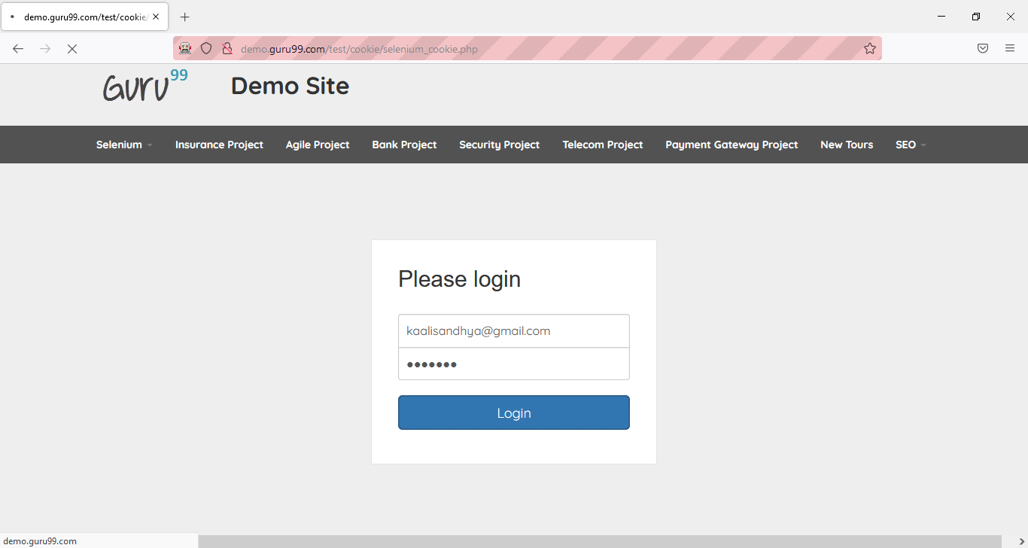

w.findElement(By.*xpath*("//*[@id=\"navbar-brand-centered\"]/ul/li[1]/ul/li[18]/a")).click();

Thread.*sleep*(2000);

w.findElement(By.*name*("username")).sendKeys("kaalisandhya@gmail.com");

w.findElement(By.*name*("password")).sendKeys("1234567");

w.findElement(By.*name*("submit")).click();

Thread.*sleep*(3000);

w.navigate().back();

w.navigate().back();

TC_37-To Open the Cookies Handling Demo in Selenium page

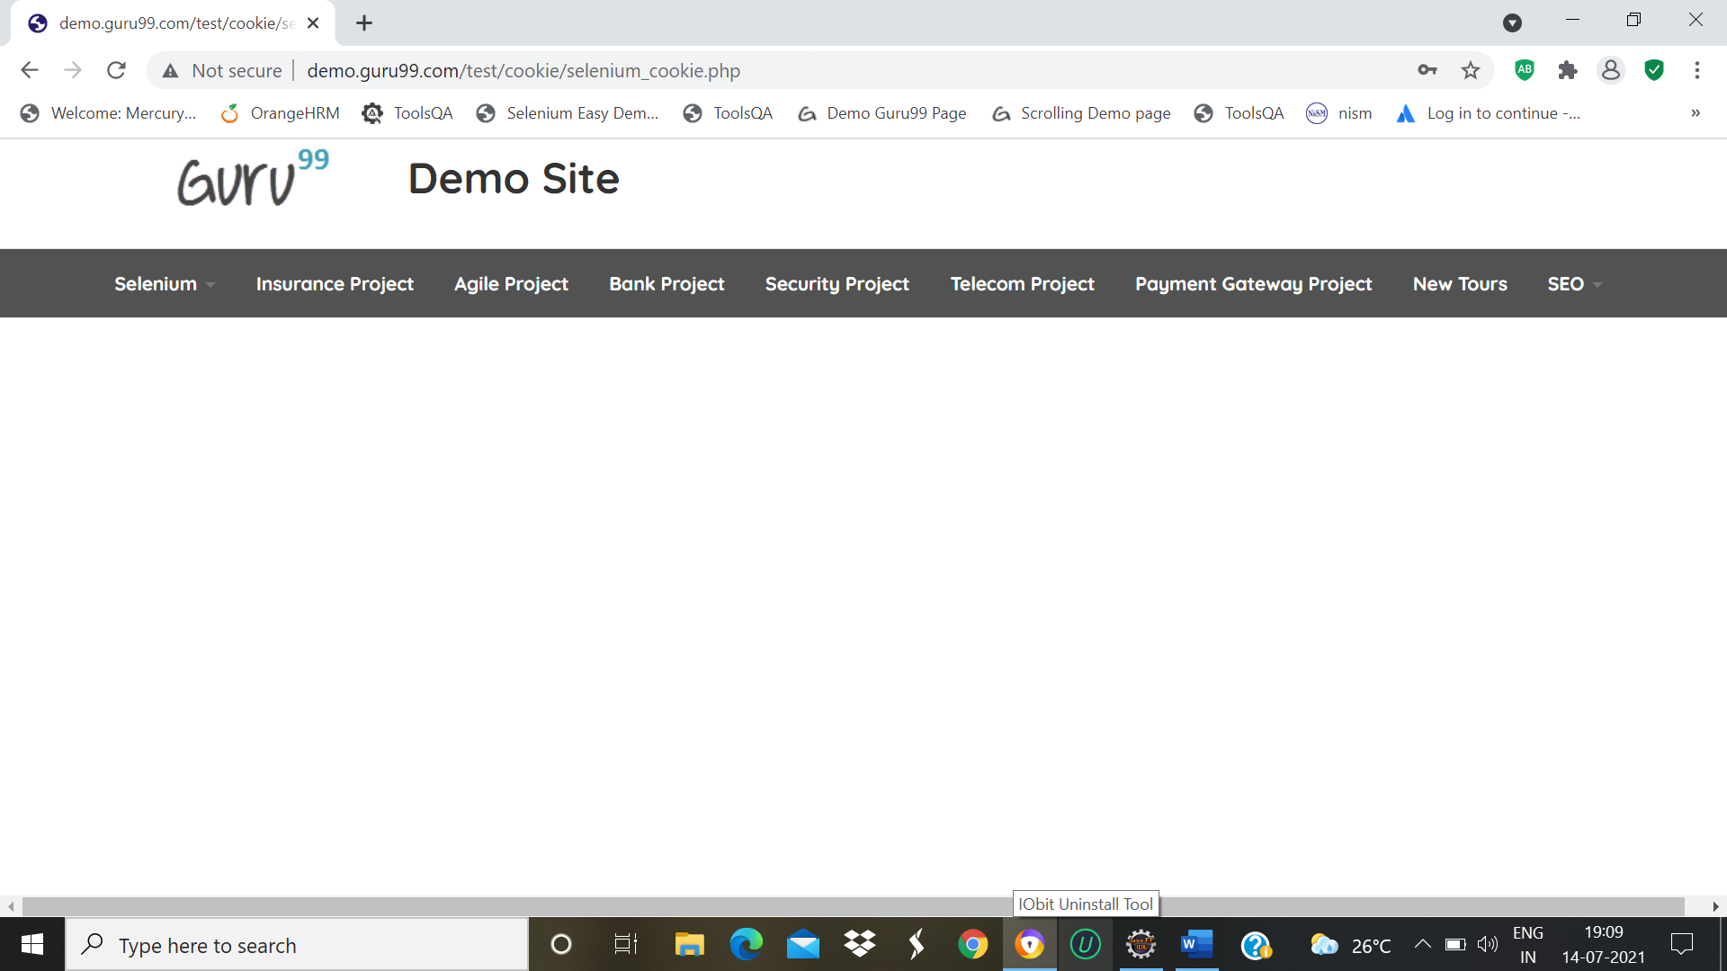

w.findElement(By.*xpath*("//*[@id=\"navbar-brand-centered\"]/ul/li[1]/ul/li[18]/a")).click();

Thread.*sleep*(2000);

w.findElement(By.*name*("username")).sendKeys("kaalisandhya24@gmail.com");

w.findElement(By.*name*("password")).sendKeys("123456");

w.findElement(By.*name*("submit")).click();

Thread.*sleep*(3000);

w.navigate().back();

w.navigate().back();

TC_38-To check the Functionality of Drag and Drop Action Demo in Selenium page

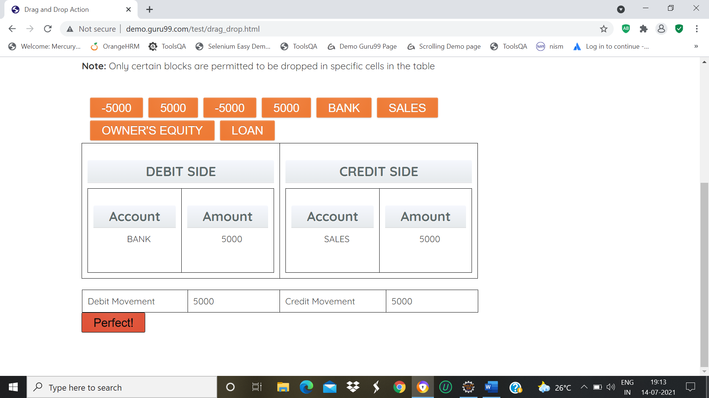

w.findElement(By.*xpath*("//*[@id=\"navbar-brand-centered\"]/ul/li[1]/ul/li[19]/a")).click();

Thread.*sleep*(2000);

WebElement Drag=w.findElement(By.*partialLinkText*("BANK"));

WebElement Drop=w.findElement(By.*xpath*("//*[@id=\"bank\"]/li"));

Actions act=**new** Actions(w);

act.dragAndDrop(Drag, Drop).build().perform();

WebElement Drag1=w.findElement(By.*partialLinkText*("5000"));

WebElement Drop1=w.findElement(By.*xpath*("//*[@id=\"amt7\"]/li"));

Actions act1=**new** Actions(w);

act1.dragAndDrop(Drag1, Drop1).build().perform();

WebElement Drag2=w.findElement(By.*partialLinkText*("SALES"));

WebElement Drop2=w.findElement(By.*xpath*("//*[@id=\"loan\"]/li"));

Actions act2=**new** Actions(w);

act2.dragAndDrop(Drag2, Drop2).build().perform();

WebElement Drag3=w.findElement(By.*partialLinkText*("5000"));

WebElement Drop3=w.findElement(By.*xpath*("//*[@id=\"amt8\"]/li"));

Actions act3=**new** Actions(w);

act3.dragAndDrop(Drag3, Drop3).build().perform();

w.navigate().back();

TC_39-To check the Functionality of Selenium Datepicker Demo in Selenium page

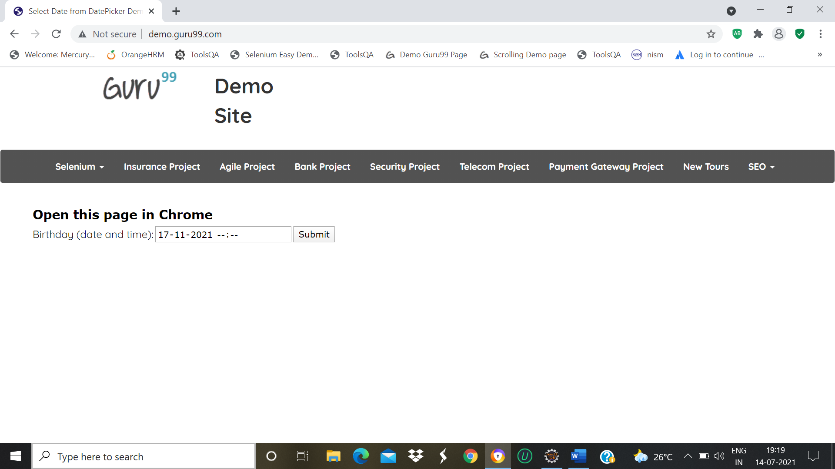

w.findElement(By.*xpath*("//*[@id=\"navbar-brand-centered\"]/ul/li[1]/ul/li[20]/a")).click();

Thread.*sleep*(2000);

w.findElement(By.*name*("bdaytime")).click();

w.navigate().back();

w.navigate().back();

DEFECT: Selection of Date Option is not working properly

TC_40-Determined the Defect in Selenium Datepicker Demo

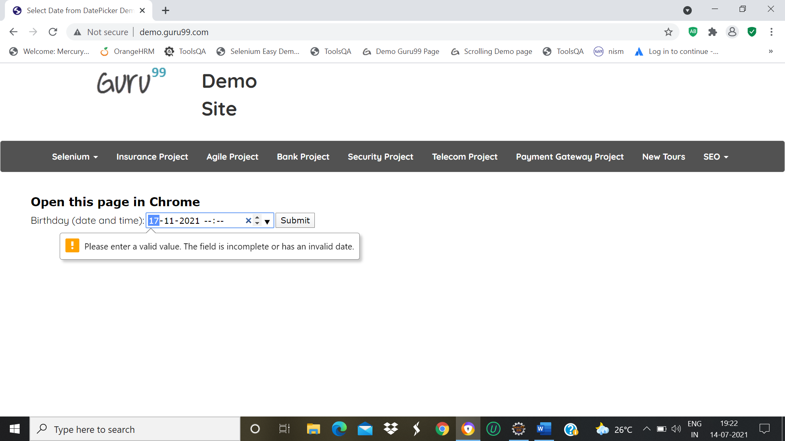

TC_41-To check the Functionality of Insurance Project in Insurance Project

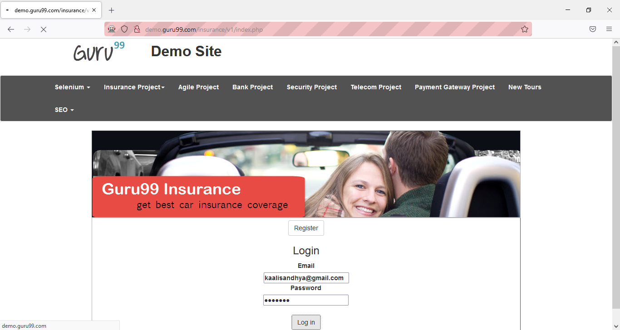

w.findElement(By.*partialLinkText*("Insurance Project")).click();

Thread.*sleep*(3000);

w.findElement(By.*name*("email")).sendKeys("kaalisandhya24@gmail.com");

w.findElement(By.*name*("password")).sendKeys("123456");

w.findElement(By.*name*("submit")).click();

w.navigate().back();

w.navigate().back();

TC_42-To check the Functionality of Login Button in Insurance Project

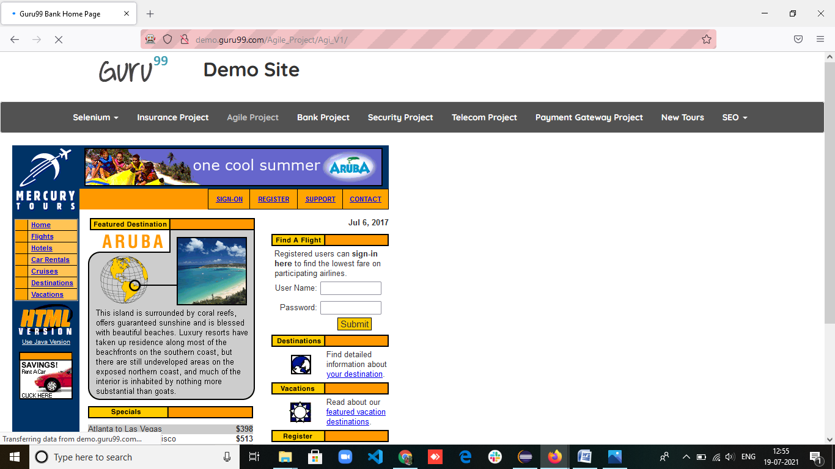

Thread.*sleep*(3000);

w.findElement(By.*name*("email")).sendKeys("kaalisandhya24@gmail.com");

w.findElement(By.*name*("password")).sendKeys("123456");

w.findElement(By.*name*("submit")).click();

w.navigate().back();

TC_43-To check the Functionality of Logout Button in Insurance Project



w.findElement(By.xpath(“/html/body/div[3]/form/input”)).click();

TC_44-To check the Functionality of Agile Project

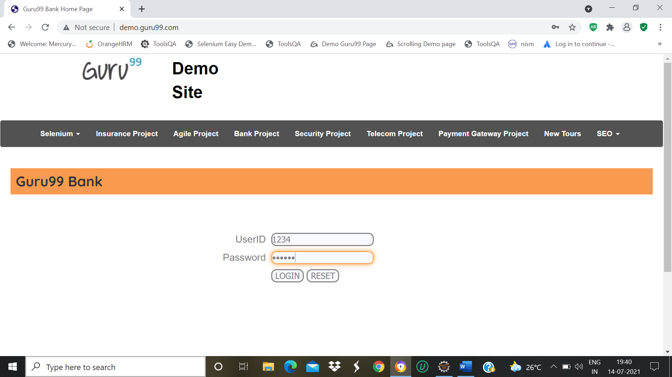

w.findElement(By.*partialLinkText*("Agile Project")).click();

Thread.*sleep*(3000);

w.findElement(By.*name*("uid")).sendKeys("1234");

w.findElement(By.*name*("password")).sendKeys("123456");

w.findElement(By.*name*("btnReset")).click();

w.navigate().back();

TC_45-To check the Functionality of Bank Project

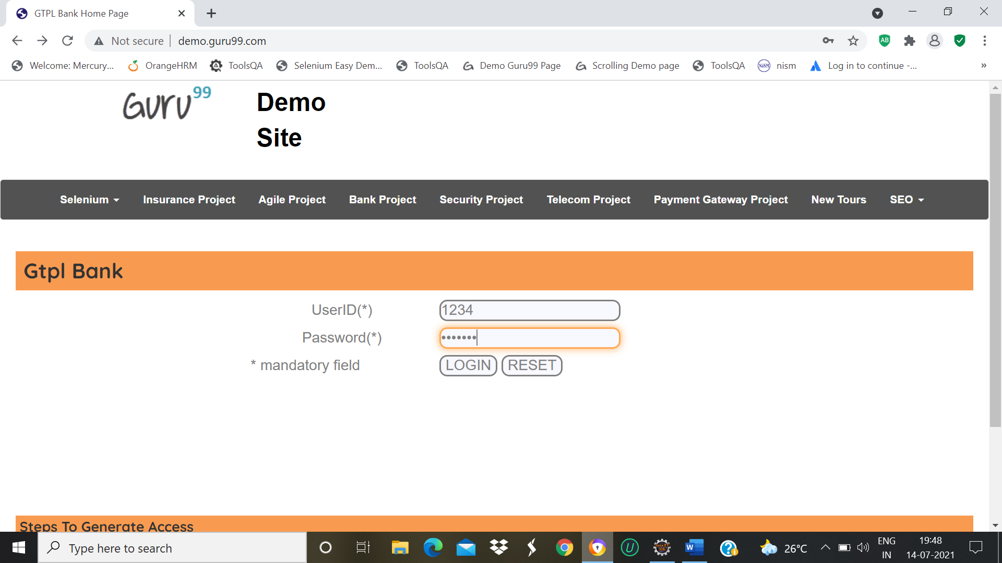

w.findElement(By.*partialLinkText*("Bank Project")).click();

Thread.*sleep*(3000);

w.findElement(By.*name*("uid")).sendKeys("1234");

w.findElement(By.*name*("password")).sendKeys("1111112");

w.findElement(By.*name*("btnReset")).click();

w.navigate().back();

w.navigate().back();

TC_46-To check the Functionality of Security Project

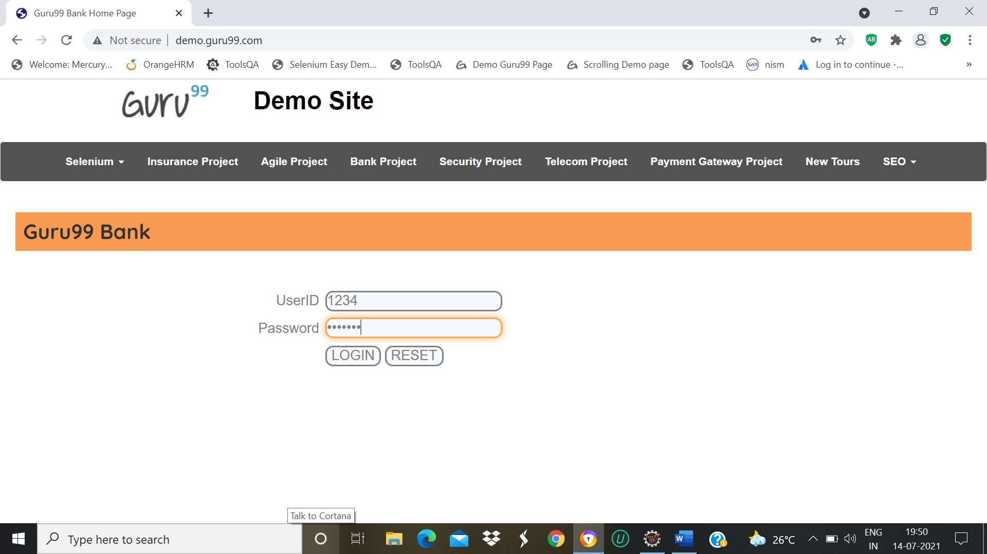

w.findElement(By.*partialLinkText*("Security Project")).click();

Thread.*sleep*(3000);

w.findElement(By.*name*("uid")).sendKeys("1234")

w.findElement(By.*name*("password")).sendKeys("1111112");

w.findElement(By.*name*("btnReset")).click();

w.navigate().back();

w.navigate().back();

TC_47-To check the Functionality of Telecom Project

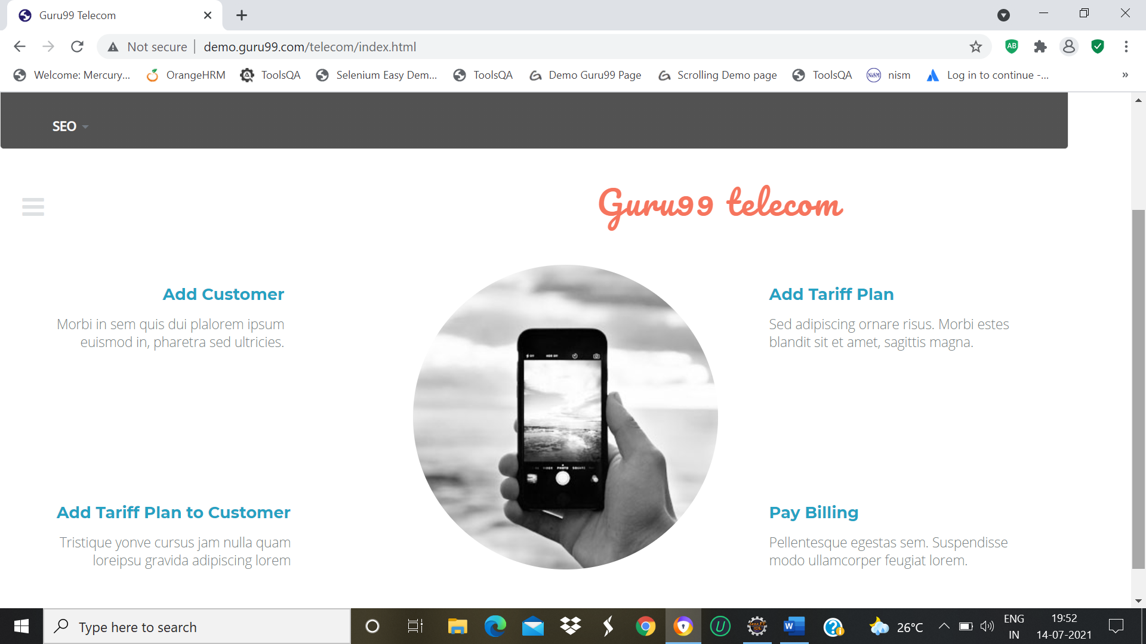

w.findElement(By.*partialLinkText*("Telecom Project")).click();

Thread.*sleep*(3000);

w.navigate().back();

TC_48-To check the Functionality of Payment Gateway Project

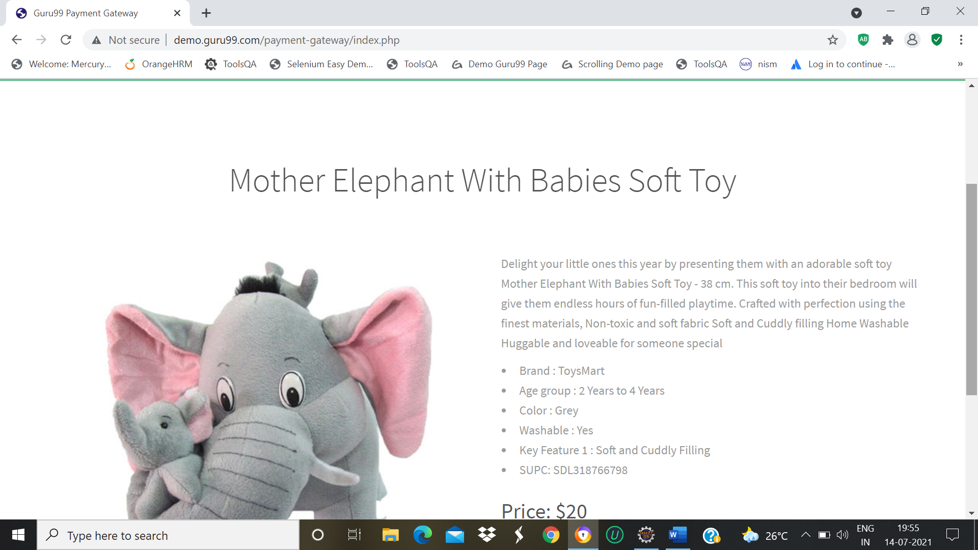

w.findElement(By.*partialLinkText*("Payment Gateway Project")).click();

Thread.*sleep*(3000);

w.navigate().back();

TC_49-To check the Functionality of Buy Now in Payment gateway Project

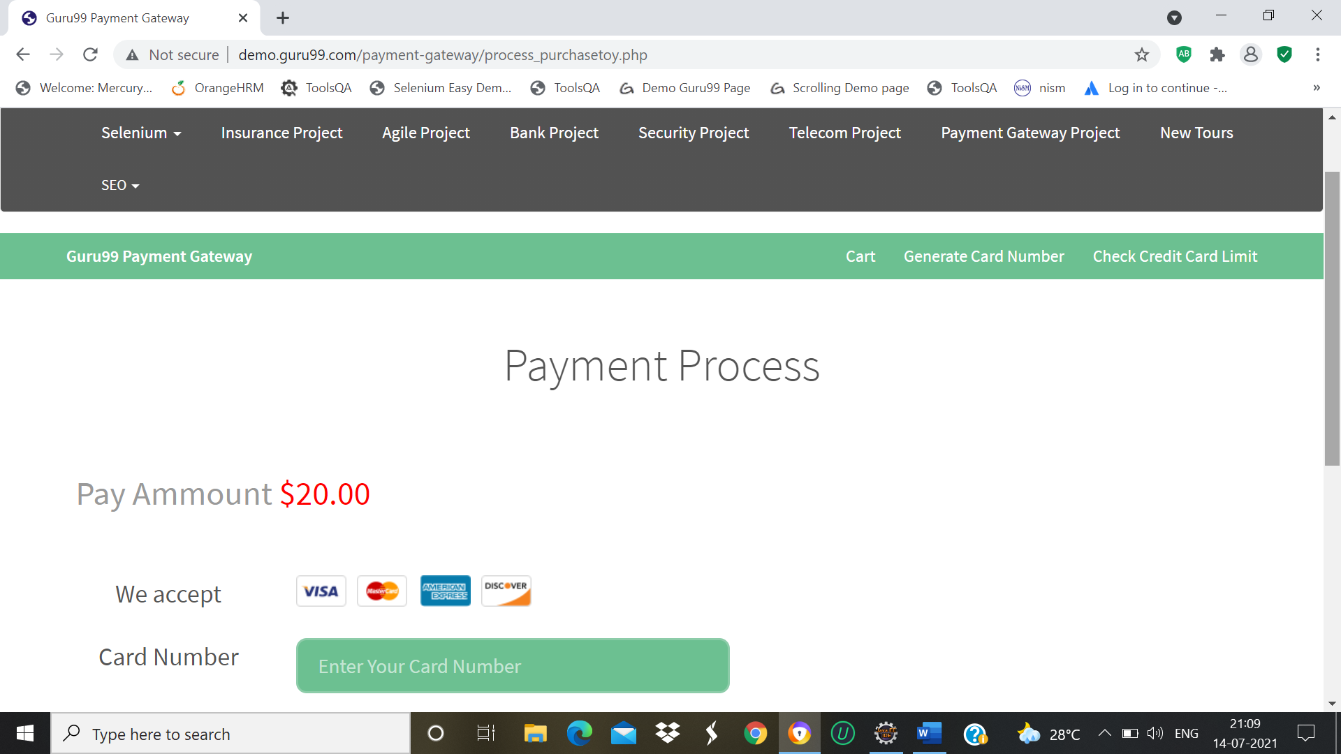

w.findElement(By.xpath(“//*[@id="three"]/div/form/div/div[8]/ul/li/input”)).click();

Thread.sleep(2000);

w.navigate.back();

TC_50-To check the Functionality of New Tours Page

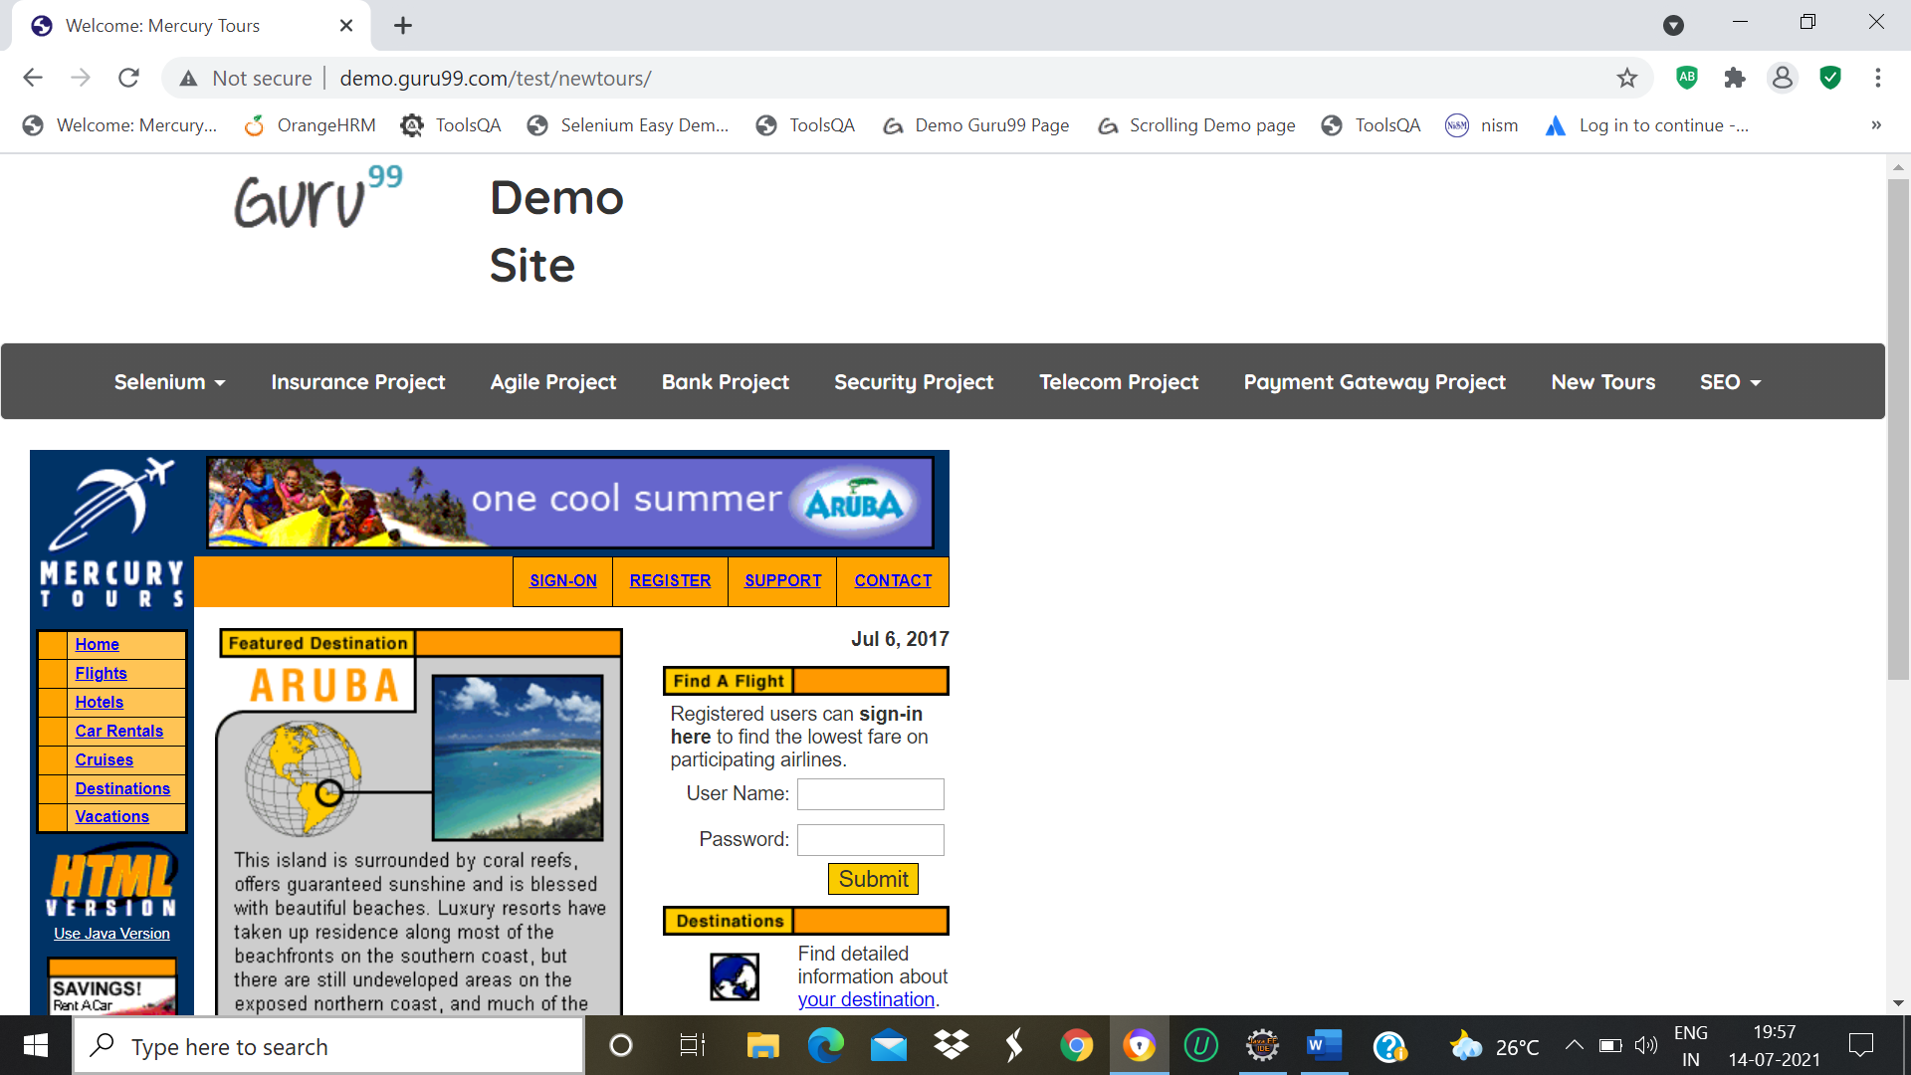

w.findElement(By.*xpath*("//*[@id=\"navbar-brand-centered\"]/ul/li[10]/a")).click();

Thread.*sleep*(2000);

TC_51-To check the Functionality of SEO Page

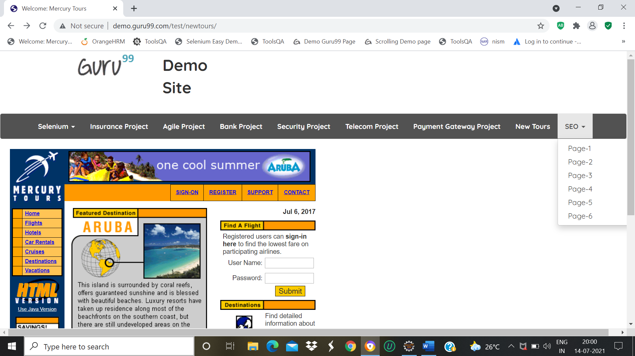

w.findElement(By.*xpath*("//*[@id=\"navbar-brand-centered\"]/ul/li[11]/a")).click();

Thread.*sleep*(3000);

w.navigate().back();

TC_52-To check the Functionality Page1 of SEO Page

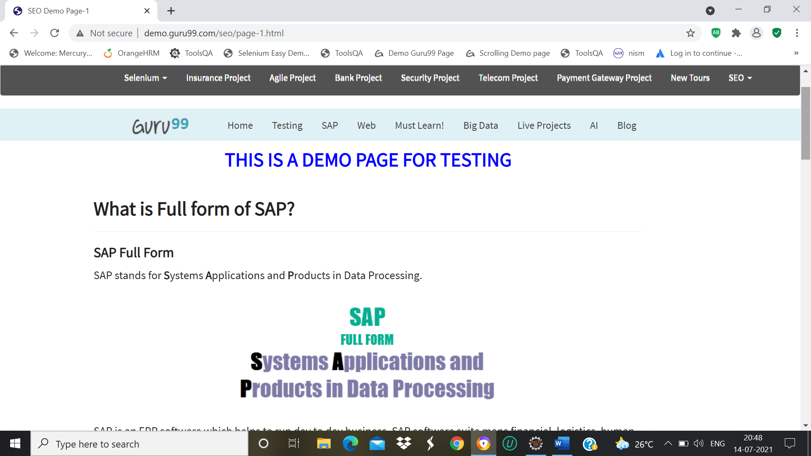

w.findElement(By.*linkText*("Page-1")).click();

Thread.*sleep*(3000);

w.navigate().back();

TC_53-To check the Functionality Page2 of SEO Page

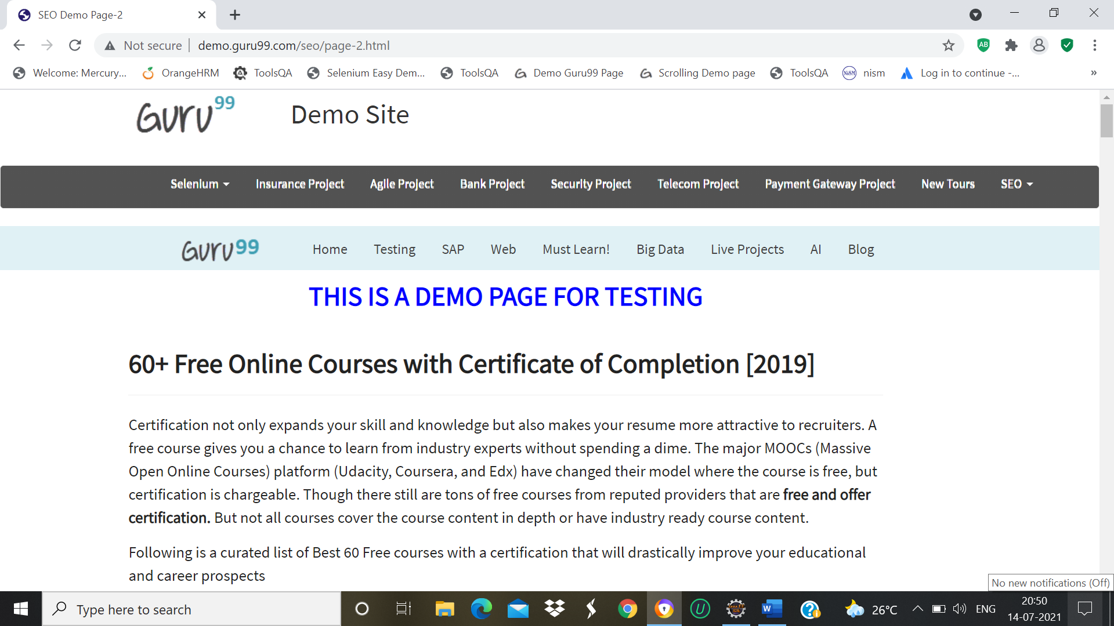

w.findElement(By.*xpath*("//*[@id=\"navbar-brand-centered\"]/ul/li[11]/a")).click();

Thread.*sleep*(3000);

w.navigate().back();

TC_54-To check the Functionality Page3 of SEO Page

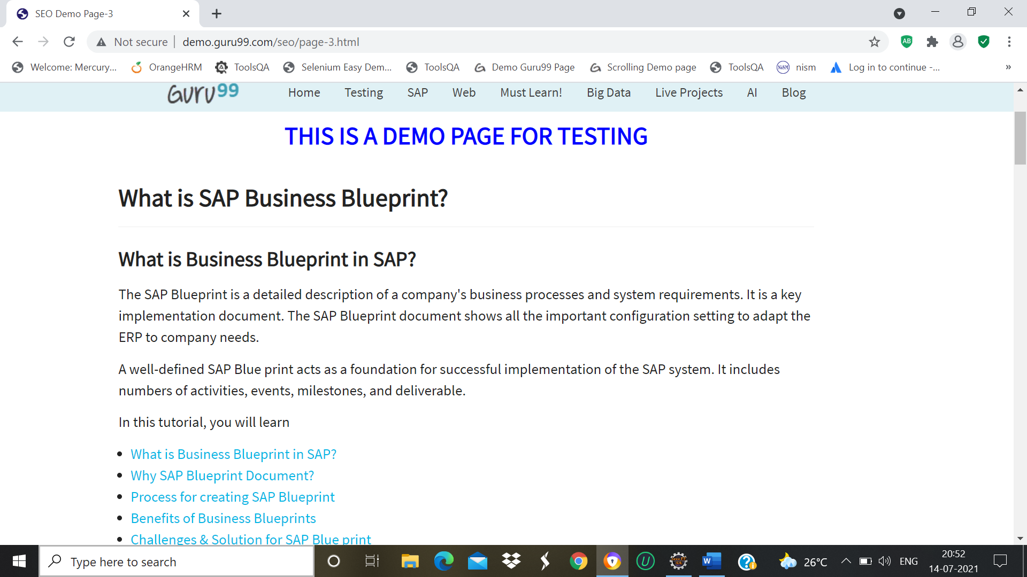

w.findElement(By.*xpath*("//*[@id=\"navbar-brand-centered\"]/ul/li[11]/a")).click();

Thread.*sleep*(3000);

w.findElement(By.*linkText*("Page-3")).click();

Thread.*sleep*(3000);

w.navigate().back();

TC_55-To check the Functionality Page4 of SEO Page

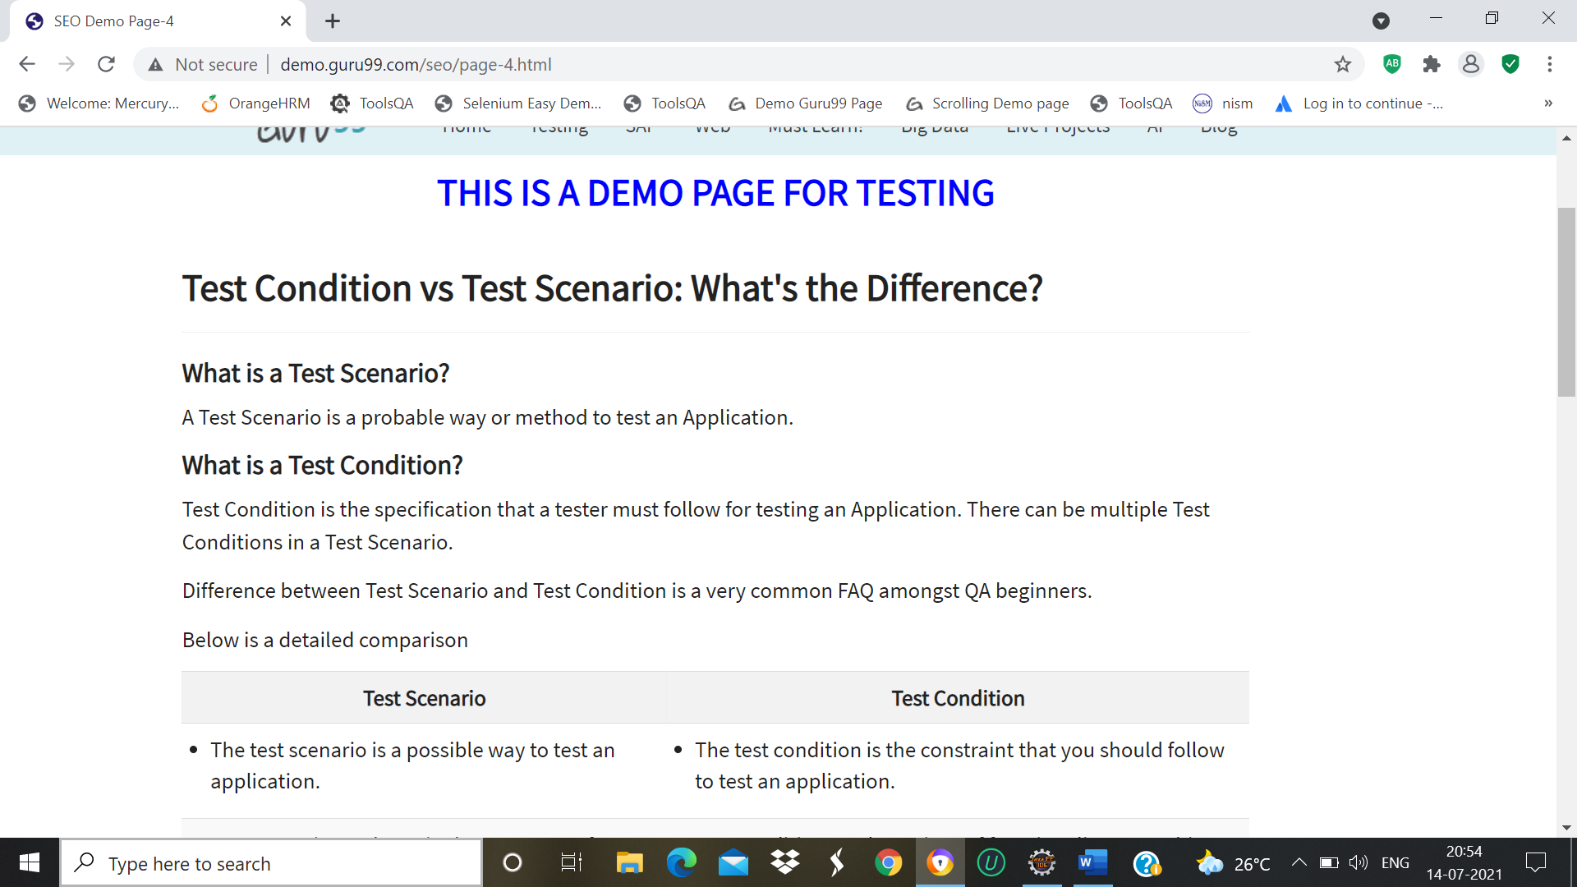

w.findElement(By.*xpath*("//*[@id=\"navbar-brand-centered\"]/ul/li[11]/a")).click();

Thread.*sleep*(3000);

w.findElement(By.*linkText*("Page-4")).click();

Thread.*sleep*(3000);

w.navigate().back();

TC_56-To check the Functionality Page5 of SEO Page



w.findElement(By.*xpath*("//*[@id=\"navbar-brand-centered\"]/ul/li[11]/a")).click();

Thread.*sleep*(3000);

w.findElement(By.*linkText*("Page-5")).click();

Thread.*sleep*(3000);

w.navigate().back();

TC_57-To check the Functionality Page6 of SEO Page

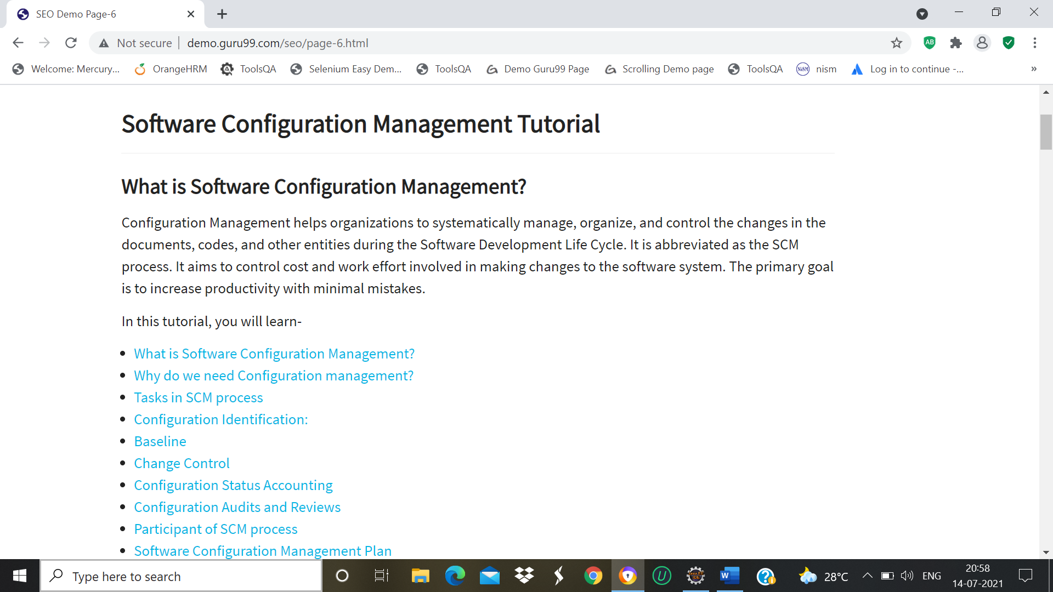

w.findElement(By.*xpath*("//*[@id=\"navbar-brand-centered\"]/ul/li[11]/a")).click();

Thread.*sleep*(3000);

w.findElement(By.*linkText*("Page-6")).click();

Thread.*sleep*(3000);

w.navigate().back();

Console Window

